


GKCS Pre-school

Home learning pack
Dear Parents and Carers
We understand that it may be difficult to keep your child busy during this time. Here are some ideas that we have pulled together to keep them busy and help you continue their learning at home. These activities are based around key areas of development that the children are currently working on at pre-school.

It would be lovely if you could upload some of your child’s amazing learning on Tapestry for us to see. We hope you enjoy these activities and have fun learning together!

Reading
- Get reading and fire up your child’s imagination! Read a book (or more) every day (if you run out of books or need some variety there are online books available, e.g. try https://www.booktrust.org.uk/books-and-reading/have-some-fun/storybooks-and-games/)
- When reading - talk about the setting, characters and how they are feeling. Talk about the beginning, middle, end of the story. Ask open questions e.g. ‘I wonder what is going to happen?’, ‘I wonder why they did that?’ Talk about different potential endings. Can your child contribute their own ideas?
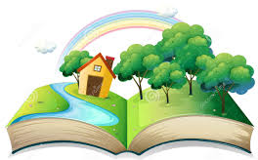

Mark-making
- Colouring – improve their pencil control with some colouring. Some sheets are attached but please feel free to create your own, linked to the book you have been reading or our child’s interests
- Drawing – encourage your child to draw – themselves, their family, their house, what they can see around them e.g. trees. They could draw their favourite story character, favourite meal, favourite pudding, favourite fruit (they could even attempt a still life!)
- Practise writing their name. Please encourage them to use a capital letter at the start of their name and the lower case for the remaining letters. For those that find this difficult, practise writing the first letter in their name, with dotted lines for them to write over. If your child can already write their name, you could practise writing numbers 1-10

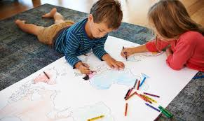

Physical development
- Keep your child’s fitness levels up with online exercise videos – try Just Dance, Sticky Kids and Cosmic Yoga
- Encourage your child to dress and undress themselves, putting their shoes and coat on, and why not teach them to do the zip up on their coat
- Play with playdough. If you have the resources already you could make your own https://www.bbcgoodfood.com/howto/guide/playdough-recipe or try mixing conditioner and flour together. What can you make? Look up ideas online to inspire your child e.g. pressing objects in to the playdough, making playdough monsters, use it as a base for building with lollipop sticks etc.
- Practise cutting skills. Make a collage out of old magazines/brochures/ birthday cards
- Keep drawing and colouring!
- Encourage your child to help out round the house – helping with the washing up, doing the laundry (lifting wet cloths and pegging on to the washing line), sweeping up inside and outside, helping with vacuuming, helping to clean the patio windows are all good exercise and your child will hopefully enjoy being helpful (as well as you getting some help with the housework)

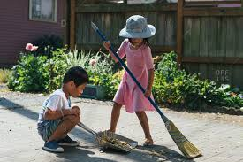

- Practise throwing, catching and kicking balls of various sizes outside
- Create a hopscotch outside with chalk, practise hopping, jumping and recognising numerals
- Indoor bowling - use some empty plastic bottles and set them up as pins before taking a soft ball to bowl them over. How many did they knock over? How many are left?
- Make an obstacle/fitness course in the garden e.g. jumping over sticks, hopping and walking along planks

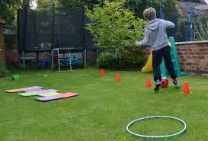

Maths
- Practise counting objects as your child plays and helps around the house e.g. count how many dinosaurs you have. Count how many plates you need for dinner, how many more do you need?
- Play topmarks games online (counting and recognising numerals) https://www.topmarks.co.uk/ (search by Maths and Early Years)
- Play board games (e.g. snakes and ladders) together, practise taking turns, counting how many spaces you have moved, how many you want to get, recognising the patterns on the dice, think about remembering where the cards are that you’ve already looked at etc
- Play card / memory games (e.g. matching pairs) – encourage your child to remember where the card they need is and which ones they have already looked at
- Create dot-to-dot pictures to help your child recognise numbers and the order that numbers go in (to either 10 or 20 depending on which numerals they currently recognise)

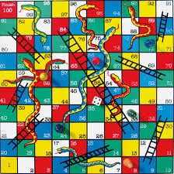

Creative
- Junk modelling or construction materials (e.g. lego, stones etc), e.g. can you create a castle or a house? Can you make a rocket?
- Do some cooking together, follow instructions, measure ingredients, talk about the importance of washing hands!
- Make a den or a fort together, or go camping inside
- Have a teddy bears picnic – can the children help make the picnic food (e.g. make sandwiches etc)?
- Do some painting, explore how colours mix together to make new colours. Some ideas : painting daffodils, painting animals, painting family members etc. Encourage your child to talk about what they’ve created, developing their language skills and boosting self-confidence
- Role play – set up a shop and go shopping for a birthday present e.g. ‘I’m looking for a present for a baby, she would something soft and cuddly and she likes stripy patterns’
- Make your own musical instruments – use empty cereal boxes, cardboard tubes and some rubber bands to create a guitar, or fill an empty container with dried pasta to create a homemade shaker
- Put on a show – this could be acting, singing, playing instruments or dancing. If your child finds this hard, encourage them to act out a story they already know e.g. the three little pigs, little red riding hood etc.
- Sing nursery rhymes together, talk about what the words mean e.g. in Jack and Jill – what is a pail of water?
- Learn some new songs - have a look on the bbc website for some good quality nursery rhyme songs and videos https://www.bbc.co.uk/teach/school-radio/nursery-rhymes-songs-index/zhwdgwx

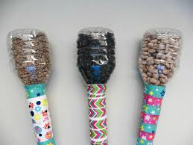

Understanding the world
- Look at family photos together – talk about important events such as family get-togethers, birthdays etc.
- Get outside to do some digging, weeding and planting
- Talk about the changing seasons. Observe changes in the world around us e.g. leaves growing on trees, different flowers coming out, the weather
- Make some animal/dinosaur homes or fairy lands outside with natural resources e.g. sticks, leaves, grass, stones, mud etc
- Learn about different animals – either zoo, farmyards or pets. Can you draw the animal, where it lives and what it eats?





