Guided Reading
You have a book with you from your Guided Reading Group.
- Spend 10 minutes reading this book with an adult every day.
- Talk to your adult about what is happening in the book and what you think might happen next.
- Choose an activity from the table below each day, choosing different ones on different days.

Create a new title page for your book. Include a picture, title, author and illustrator.  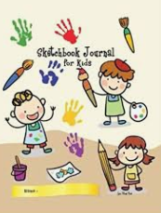 | Write a wanted poster to help locate a character from your book.  Remember to include:  - Their appearance  - Their behaviour  - What they have done  - A reward!  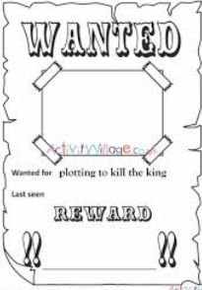 | Choose the 5 most important events that have happened in your book and create a comic strip to show these.  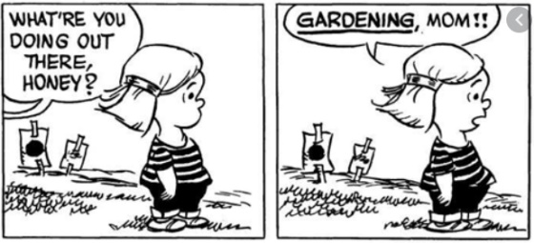
Draw a picture of your character to show how they are feeling and acting at this point in the book.  Give them a speech bubble and write carefully in it, to show what they might say. Can you write a piece of conversation underneath using the correct punctuation we have taught you for speech?   | Create a character profile for your favourite character in the book.  - Draw your character  - List their likes and dislikes  - What are their hobbies?  - What are their future plans?  - Who are their friends and enemies?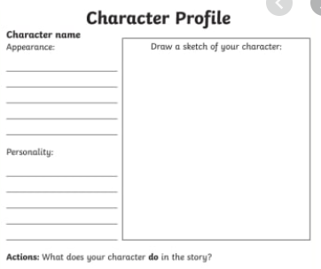 | Choose one page of your book.  Identify all the adjectives on the page and make a list of them.  Try using these adjectives in your own sentences.  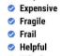
Choose a page of your book.  Identify all the powerful verbs that you can find and make a list. Can you find alternative verbs for each of these, so that you keep a similar meaning but make the story more interesting?  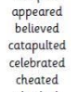 | Make a list of useful vocabulary from you book:  - Make a list of all the great words that you love in the book  - Think about how you could use some of these words in your writing  - Try writing some new sentences with 5 of these words  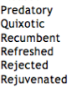 | Change the ending!  Write an alternative solution and ending for your book.  Can you make it more interesting?  Can you write the ending you wanted to see?  

