Space
Reception – Autumn 2
Important People
I will learn that…
Katherine Johnson loved going to school to learn mathematics. Using what she had learnt, she helped NASA send astronauts to the moon!
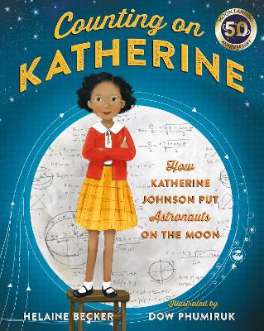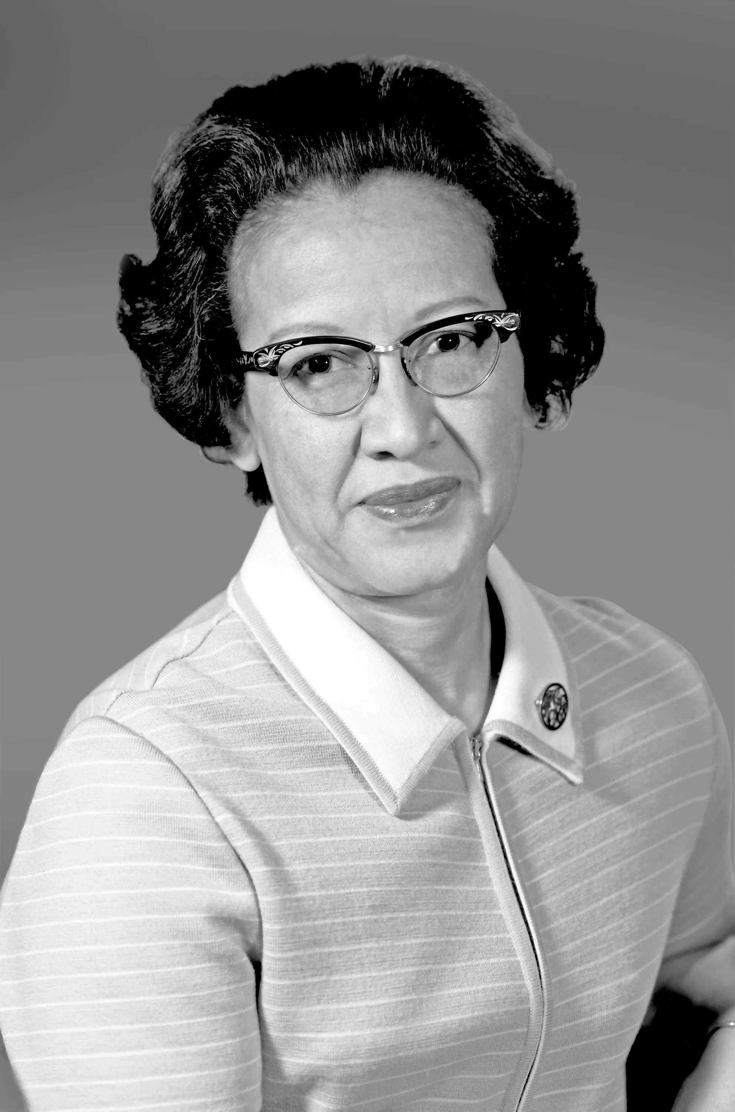

WOW Words
Words I will learn
- Space
- Planets
- Moon
- Sun
- Stars
- Rockets
- Astronauts
- Gravity

Class Trips
Post Office & Methodist Church Visit
We will write letters to Santa asking him what we wish to have this Christmas and visit the church to listen to the Christmas story.
We will be walking to the Post Office and sending all our letters off to the North Pole! 
Core Books
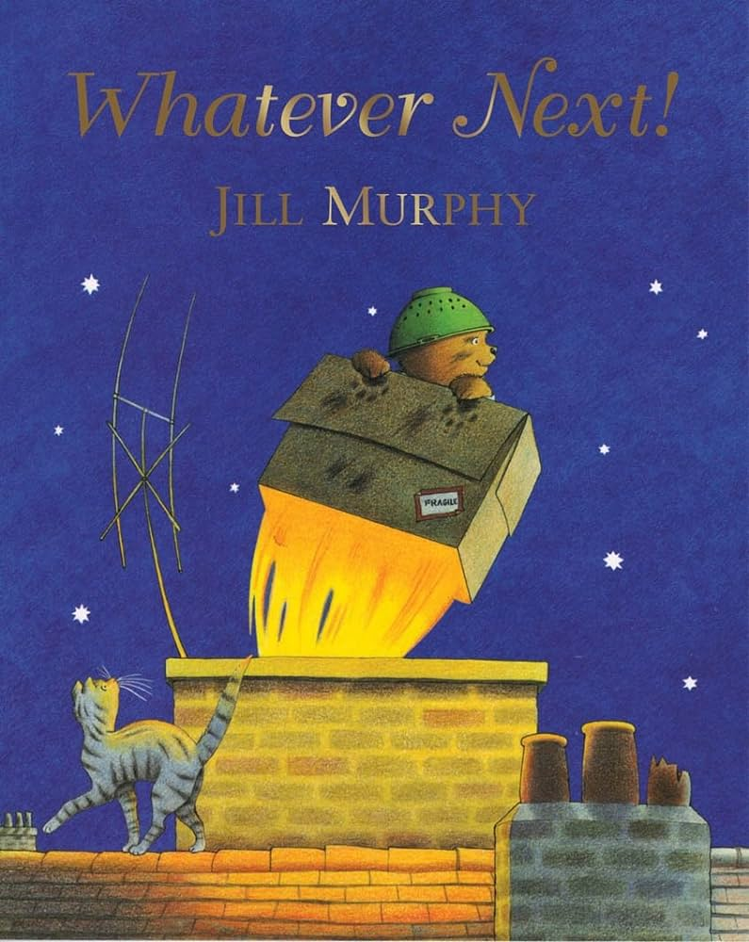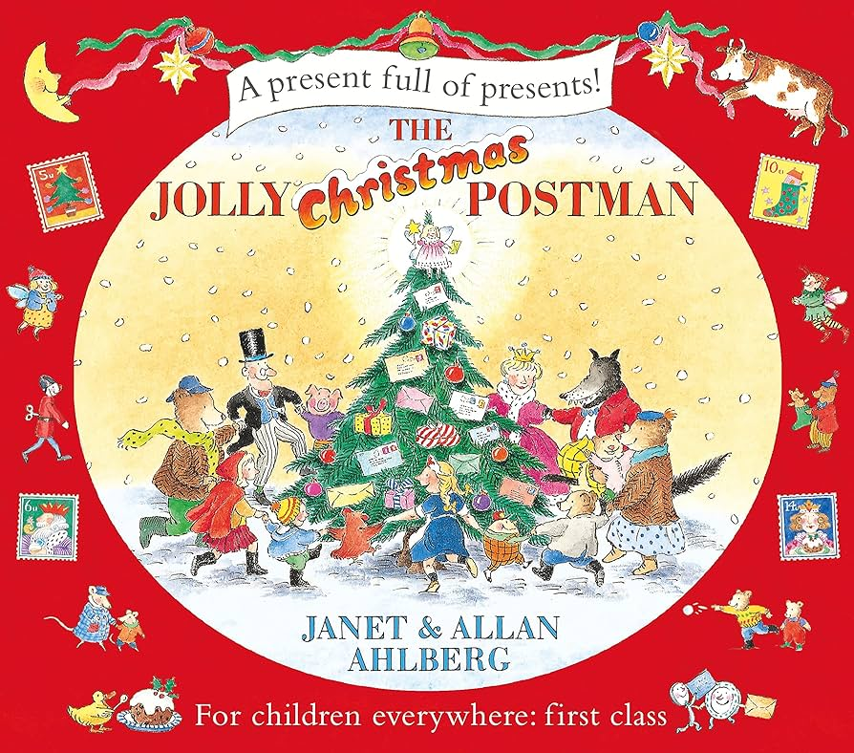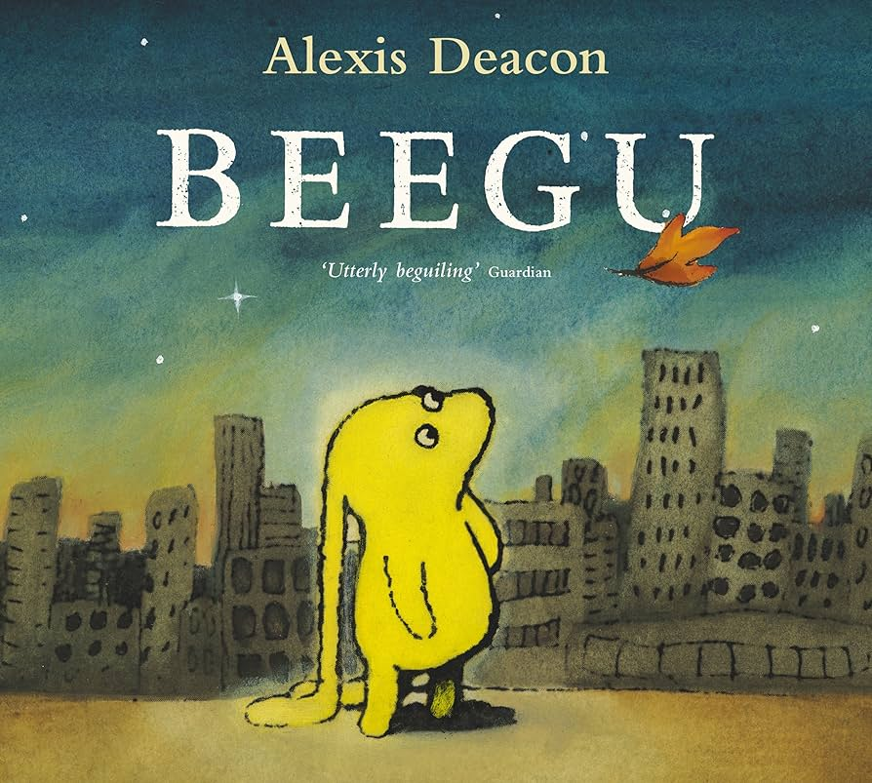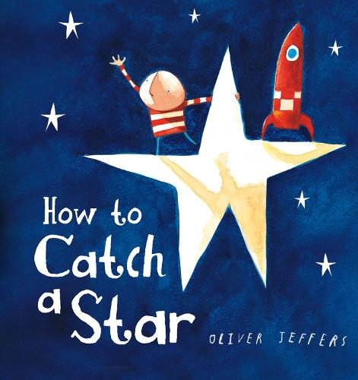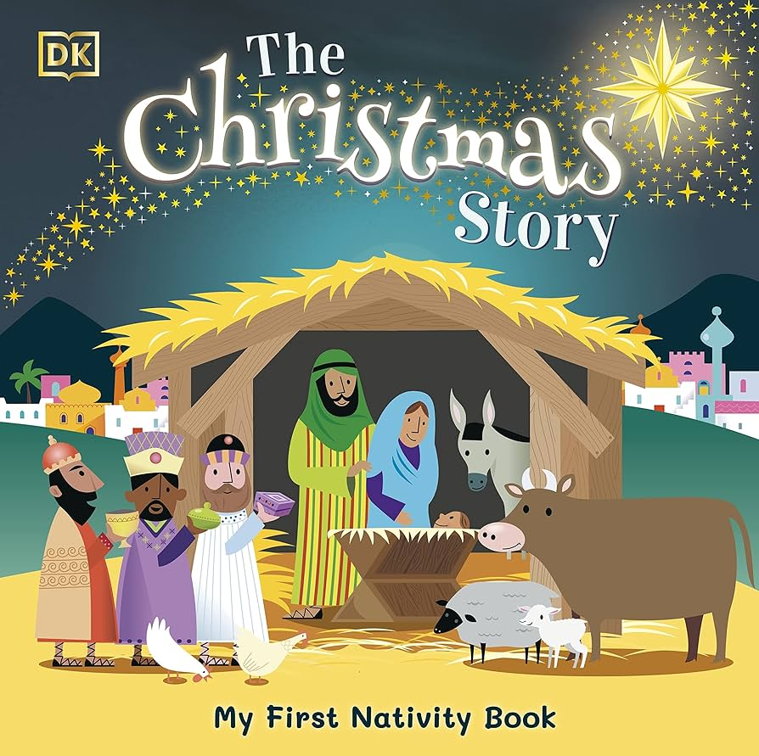
Key Learning
I will learn that…
- There are 8 planets in our Solar System
- We live on Planet Earth
- Astronauts visit space and learn all about the different planets
- There are changes within every season
I will be able to…
- Build fine motor skills through cutting, scrunching and sticking
- Write a list of what I would take to the moon
- Create rockets using junk modelling
- Design astronauts’ suits
- Complete sentences about how to be safe during Bonfire Night
- Write what noises fireworks make
- Write a letter to Santa
- Count to 10 using a ten frame
- Discuss the features of 2D and 3D shapes

