Key vocabulary
Castle – A large building built to protect people during wars and battles | 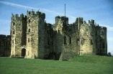
Monarch – A person who reigns over a kingdom like a King or Queen | 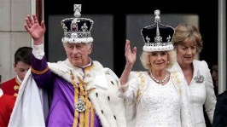
King or Queen - Male or female ruler of a country. | 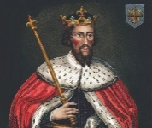
Coronation - The ceremony of crowning a King or Queen. | 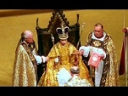
Turret - A small tower built on the castle on the corner, or on top of a large tower. | 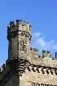
Motte and Bailey - Motte means a mound of “clod of earth” and bailey means an enclosure. | 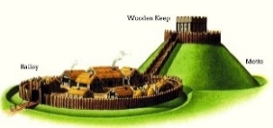
Moat - A deep, broad ditch, either dry or filled with water, that is dug and surrounds a castle to prevent attackers from getting inside easily. | 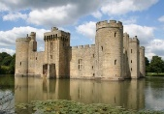
Portcullis – Iron or wooden gating that hangs in the entry to a castle . | 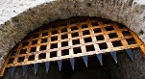
Capital city – Each country has a capital city. London, Cardiff, Edinburgh, Belfast. | 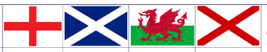
Year 1
Autumn 1 - Captivating Castles

Key Learning:
To name, locate and identify characteristics of the four countries and capital cities of the UK and its surrounding seas.

To discuss and describe important historical events, people and places.

To discuss and describe changes in history.

Useful websites:

https://www.dkfindout.com/uk/history/castles/
Castles and Knights - BBC Teach

BBC iPlayer - Go Jetters - Series 1: 38. Caernarfon Castle, Wales
Castles around the United Kingdom:
Windsor Castle Warwick Castle
Edinburgh Castle Stirling Castle Caernarfon Castle Belfast Castle
Kilkenny Castle
Did you know?
In Medieval times there were three main types of castles: the motte-and-bailey, stone keep, and concentric castles.

The first castles were built by the Normans. The great age of castles began almost 1,000 years ago and lasted for nearly 500 years.

King Charles 3rd was born on 14th November 1948. He was crowned King on 6th May 2023.

