Key vocabulary
Continent (A continent is a large solid area of land. Earth has seven continents) | 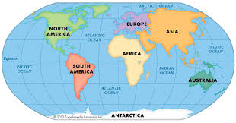
Compass (an instrument used for finding directions) North, South, East, West | 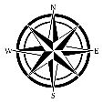
Arctic – regions around the North Pole | 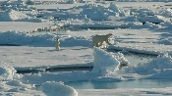
Antarctic – the South Polar region | 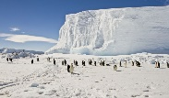
North and South Poles – the northern and southernmost points on Earth. | 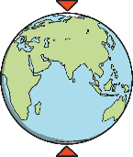
Equator - an imaginary circle around Earth. It divides Earth into two equal parts: The Northern Hemisphere and the Southern Hemisphere. | 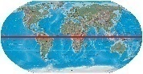
Apollo 11 – the spaceflight that first landed on the moon. | 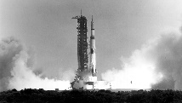
Frost bite -when parts of your body become damaged due to being very cold. | 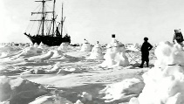
Rations -having a limited amount of food or supplies for each person. | 
Ernest Shackleton was a polar explorer who led British expeditions to the Antarctic. He was particularly interested in exploring the South Pole. He wanted to be the first person to reach the South Pole. He became very ill on the way home from his trip. On his second trip, he made it to within 97 miles of the South Pole before he had to turn back.

Explorers

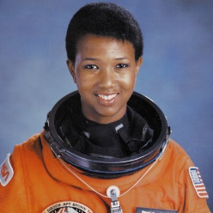
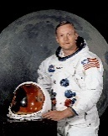
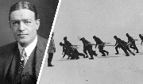
What qualities did Ernest and his men have?
Are any of these the same as our school values?
Would you like to be an explorer? Why? Why not?
Key learning:

-Name and locate the world’s seven continents and five oceans.

-Identify seasonal and daily weather patterns in the United Kingdom and the location of hot and cold areas of the world in relation to the Equator and the North and South Poles.

- Study the lives of significant individuals in the past who have contributed to national and international achievements.
Neil Armstrong was a pilot, astronaut,
and the first person to walk on the
moon.

Mae Jemison became the first black woman to travel into space when she served as a mission specialist aboard the Space Shuttle Endeavour.

Amelia Earhart was an aviation pioneer and author. She was the first female aviator to fly solo across the Atlantic Ocean.

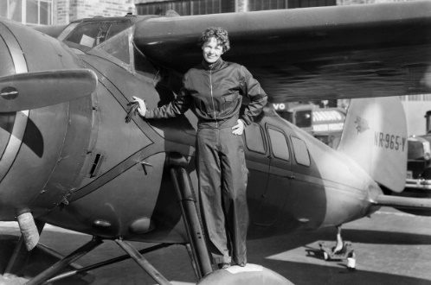

Useful websites:
- https://www.bbc.co.uk/bitesize/topics/zhpchbk/articles/z7xnn9q https://www.bbc.co.uk/bitesize/articles/zhx4k2p

