Key vocabulary
River  (a naturally winding watercourse) | 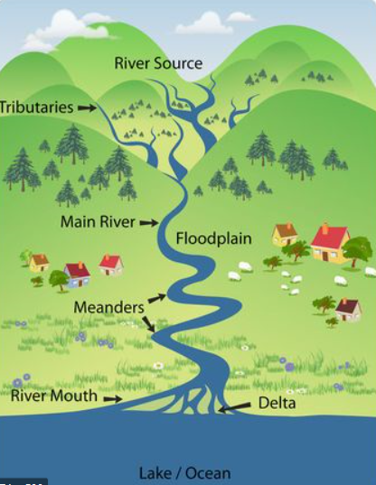  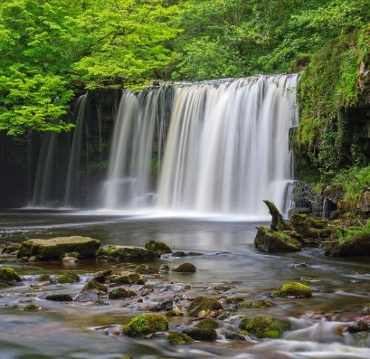  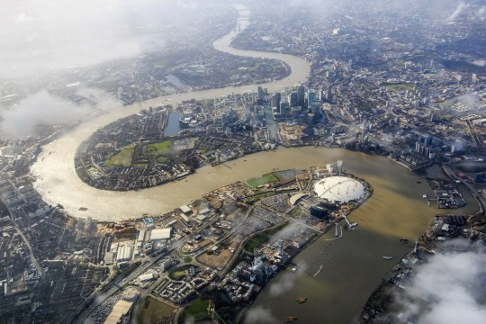
Sea
(a large body of salt water)

Source
(where a river begins)

Mouth
(the end of the river)

Flood plain
(the flat land of the river valley close to the riverbank)

Meander
(a bend in the river)

Oxbow Lake
(A small arc-shaped lake)

Waterfall
(a place where the river course is interrupted by a tall step)

Tributary
(a river or stream flowing into a larger river or lake)
Confluence
(where two streams or rivers meet)

Key learning:
- To name and locate countries in the UK and Great Britain.
- To locate the major rivers and seas in and around the UK.
- To recognise the key features of a river from source to sea.
- To identify and locate on a map the River Thames from source to mouth.
- To describe the river processes of erosion, transportation and deposition.
- To identify and describe the uses of a river.
- To understand the features of a polluted river.
- To understand what makes rivers polluted.
- To investigate if river pollution is reversable.
- To recognise and locate rivers around the UK.
- To recognise and locate rivers outside of the UK.

Raging Rivers


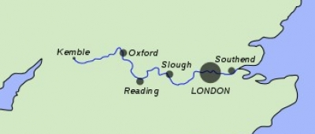
Denham Country Park:

This term we will be going to Denham Country park, led by Iver Environment Centre to go beyond the classroom and look in detail at one of our local rivers, The River Misbourne. This relates to our topic, linking to the National Curriculum objectives for Year 3. During the trip, we will look at the physical features of a river, the pollution levels and what lives in them! This will help us create wonderful Topic and English work for our Autumn Term Raging Rivers Topic.
River Thames:
The River Thames is a river
that flows through Southern
England and London.
At 215 miles (346 km), it is the longest river entirely in England and the second-longest in the United Kingdom, after the River Severn. The River Thames flows through many other major towns and cities including Oxford, Reading, Henley-on-Thames and Windsor.
The Wind in the Willows:

The Wind in the Willows is a children’s novel by
the British novelist Kenneth Grahame. It was first
published in 1908 and focuses on the adventures
of Mole, Ratty, Toad and Badger who live
alongside the Thames riverbank and the nearby
Wild Wood. This will be our Autumn Guided Reading text.
Did you know that ‘The Wind in the Willows’ began as a bedtime story for Kenneth Grahame’s son Alistair?





