KEY VOCABULARY
Military  - The most powerful in the ancient world, separated into legions (5,000 men), cohorts (480 men), and centuries (80 men). | 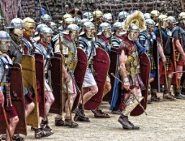
Soldiers  - There were two main types of soldier: legionary - an elite, Roman citizen soldier; auxiliary – a  non-Roman citizen. | 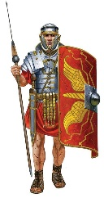
Bath house  - One in every town, a place for washing and relaxing.  - Included a tepidarium (warm bath), a caldarium (hot room), and a frigidarium (cold bath). | 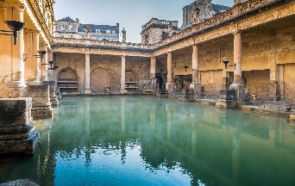
Towns  - Bigger Roman towns would include an amphitheatre, baths, forum (market), basilica (town hall) and a temple (for worshipping). | 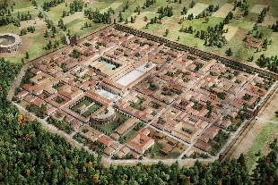
Boudicca  - The queen of the Iceni Tribe who led a Celtic army to fight the Romans. | 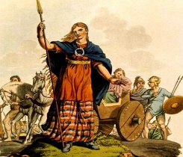
Hadrian’s Wall  - Built by Roman Emperor Hadrian to defend the Romans from the unconquered Scottish Celts. | 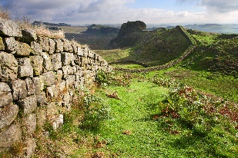
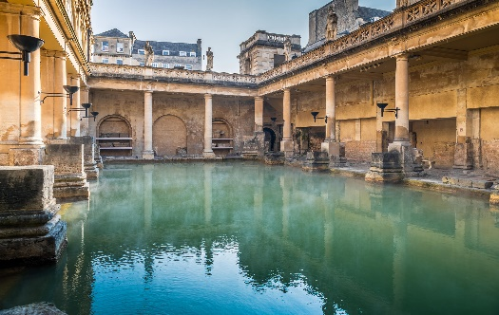
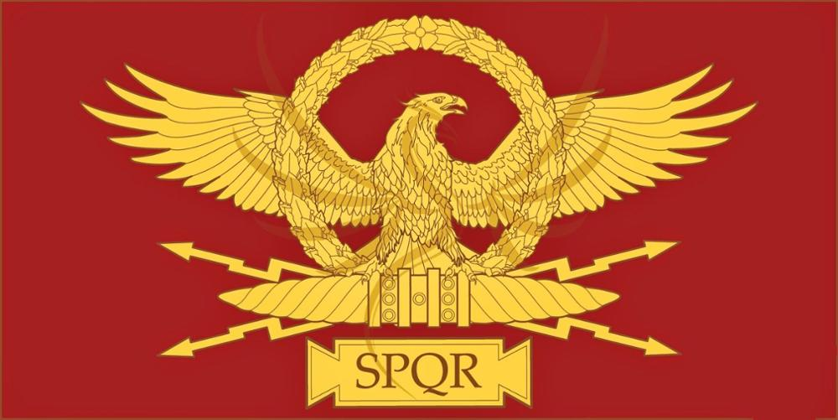
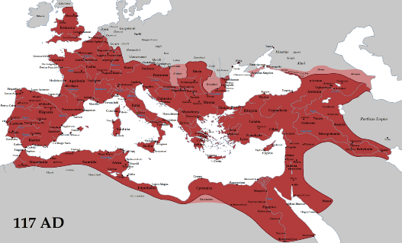
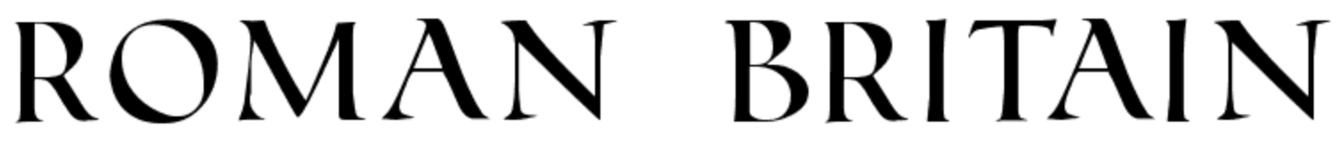
KEY LEARNING:
- To understand the extent of the Roman Empire and which countries fell to the power of the Romans. To consider how this impacted people living in Britain at the time.
- To identify the features of the main parts of Roman civilisation including: the buildings and layout of towns; the bath houses; roads and transport; social hierarchy; the army and religion.
- To discover more about the Roman way of life through artefacts.
- To recognise the achievements and legacies the Romans left for us in Britain and consider the impact this has had on how we live our lives today.
USEFUL WEBSITES:
https://www.bbc.co.uk/bitesize/topics/zwmpfg8
http://primaryhomeworkhelp.co.uk/Romans.html
https://www.historyforkids.net/ancient-rome.html

Year 4 – Autumn Term

