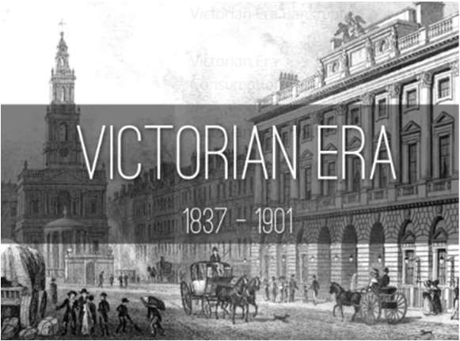

The Victorian period is named after Queen Victoria who reigned over Britain and a world Empire from her coronation in 1837 to her death in 1901 – 64 years. Life in Victorian England was very different to today. It was a time of great wealth and poverty, as well as invention and scientific discovery.

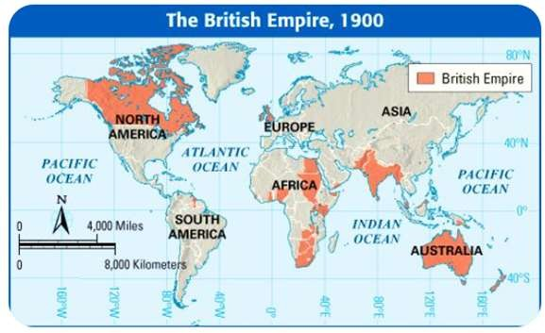
Timeline
1837 – Queen Victoria crowned (aged 18 years).
Year 5 Autumn Term
1840 – Queen marries her cousin, Prince Albert.
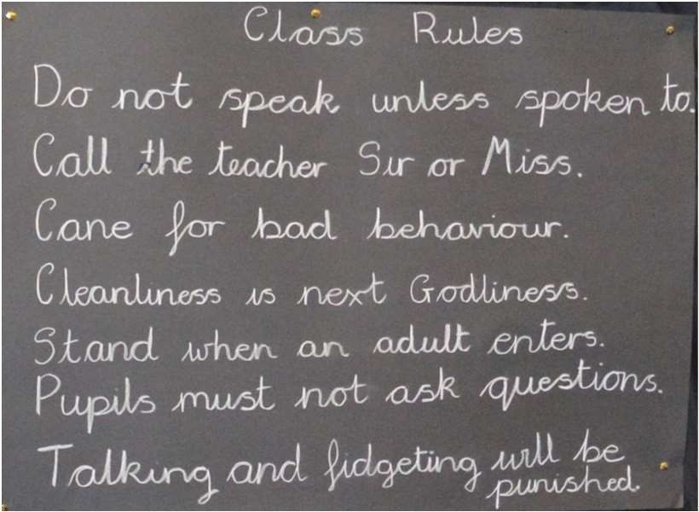
1840 – first ragged schools set up.
1844 – factory act states children could start work from age 8 but had to have 2 hours schooling daily.
1847 – factory act states women and children under 18 could only work 10 hours or less daily.
1851 – Great Exhibition. 1861 – Prince Albert dies.
1863 – first underground railway opens in London.
1867 – all factory workers limited to 10 hours work daily.
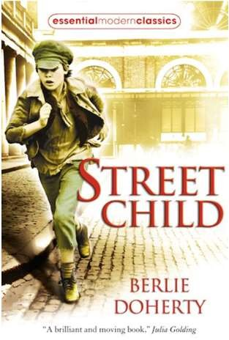
1870 – Dr Barnardo opens first home for boys.
1871 – first FA cup for football.
Useful websites
The Victorians - BBC Teach
School Learning Zone - The
Victorians (school-
learningzone.co.uk)
Victorians Homework for kids
(primaryhomeworkhelp.co.uk)
1877 – Queen declared ‘Empress of India’. 1880 – Children 5-13 required to attend school (but had to pay).
1882 – first electric power station in London. 1891 – education made free and compulsory for children 5-13.
1897 – Queen Victoria Diamond Jubilee (50 years on the throne).
1901 – Queen Victoria dies.

