Digging for Dinosaurs
How many dinosaurs do you know?
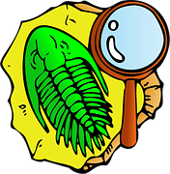
Reception – Spring 1
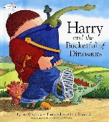
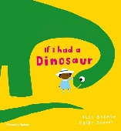
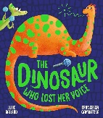
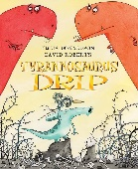
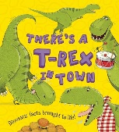
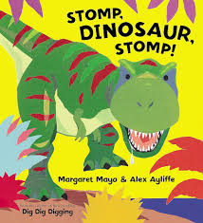
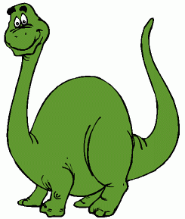
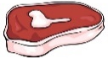
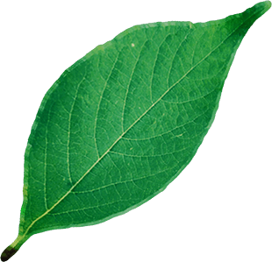
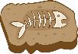
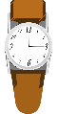
This term, we will look at what dinosaurs ate, how they moved and their similarities and differences.
We will do lots of sorting based on our own criteria, organising dinosaurs into different groups. We will also create a volcano, learn about its components and watch it erupt! We will explore fossils and think of some wonderful questions like true explorers, ready for when the Dino Lady visits us in school!
Core Books:

Which dinosaur was the biggest?
WOW Words
Picture | Word | Meaning
 | Prehistoric | The time period before written records.
 | Fossil | Remains of a plant or animal embedded in rock.
 | Herbivore | An animal that only eats plants.
 | Carnivore | An animal that only eats meat.

Resources
- Go on a dinosaur adventure with Andy! On BBC iPlayer
- Usborne pop-up dinosaurs books
- ‘Harry and the Bucketful of Dinosaurs’ stories.
- Explore different Dinosaur facts at https://www.bbc.co.uk/cbeebies/curations/dinosaur-facts
Key Learning
- In English we will be researching dinosaurs, describing dinosaurs’ features and writing fact files all about the land before time!
- In Maths we will be counting, partitioning and calculating. As well as doing lots of problem solving with the dinosaurs.
- We will explore and sing dinosaur songs, ready for our Dino Tea Party at the end of term! We will also discuss sounds that dinosaurs may have made or heard.

