Once Upon A Time…
Reception – Spring 2
Important People
I will learn about…
The Easter Story. I will explore what happened to Jesus in the Christian calendar at Easter.
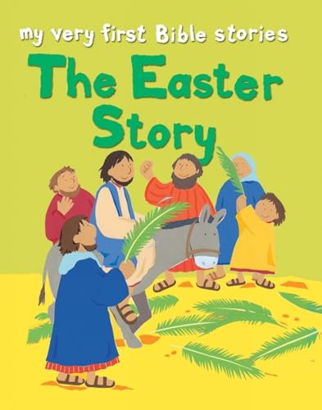

WOW Words
Words I will learn
- Once upon a time
- Fairy Tales
- Poisonous apple
- Giant
- Stranger
- Prince/Princess
- King/Queen

Class Trip
Methodist Church Visit
We will visit the Methodist Church to learn more about Easter.
Core Books
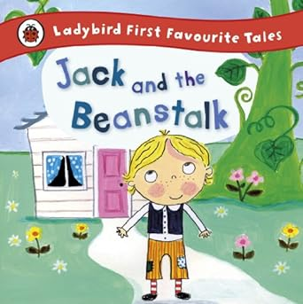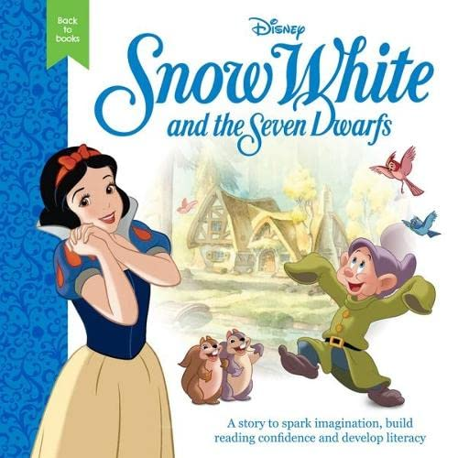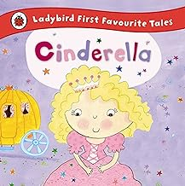
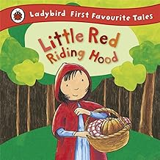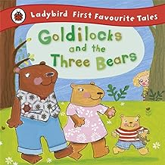
Key Learning
I will learn that…
- There are good and bad characters in Fairy Tales.
- Fairy Tales are fiction
- There are Safer Strangers who can be trusted
I will be able to…
- Retell a variety of Fairy Tales
- Discuss the key characters
- Use descriptive words to write about Fairy Tales
- Explore natural materials to test their strength to make houses for the three little pigs
- Make repeated patterns
- Recall number bonds to 10.
- Count on and back to 10

