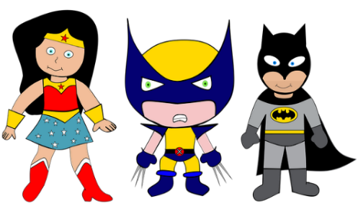
Year 1
Spring 1 – Heroes and Heroines
Significant people of focus
Greta Thunberg
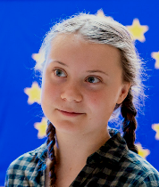
Subject specific vocabulary
Timeline | A record of events that happened displayed in order on a line.
Hero/Heroine | Someone we look to for their greatness
Impact | The effect that someone has on the future
Past | Things that have happened before the present.
Present | Things that are happening now, today.
Significant | People of great importance, who have who have done something that has changed lives.

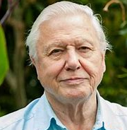
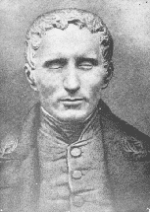
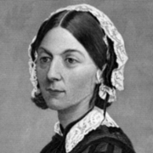
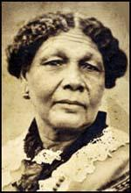
Marcus Rashford, MBE
Did you know?
A significant person is someone who made discoveries that changed the way we live our lives.
A timeline shows us how time has progressed and ordered events.
All of the above Heroes are remembered as “significant” because they changed the world with their heroic actions by helping others.

Actions
Sir David Attenborough
Louis Braille
Useful websites:
Small town superheroes game:
https://www.bbc.co.uk/bitesize/topics/zd63xyc/articles/zncgvk7
Significant figures:
Famous people from history - BBC Teach

Key learning opportunities:
To learn about the life stories of our significant people.
To learn some braille, feel and read samples, and code using Braille.
To locate our significant people on a world map using a globe, atlas, and compass directions.

Florence Nightingale
Mary Seacole

