Key vocabulary
Compass- A compass is a tool for finding direction. | 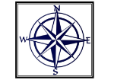  Year 1 Spring 2 - On The High Seas
Treasure (booty) wealth such as money, jewels, or precious metals. | 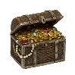
Pirate ship - a ship that is manned by pirates. | 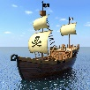
Blackbeard - Edward Teach, known as Blackbeard, was a notorious pirate who sailed the seas in the early 1700s. | 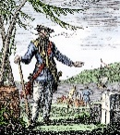
Jolly Roger - a pirate's flag with a white skull and crossbones on a black background. | 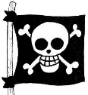
Anne Bonny - Anne Bonny was a young woman who ran away to sea disguised as a man named “Andy.” | 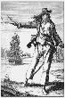
Captain - When electing a Captain, the crew looked for someone who was capable of commanding and navigating a ship. Also, it was crucial that a captain had courage and skill in both, sword and pistol fighting. | 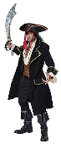
First mate - First Mate was ranked just below the Captain. He would take control of the ship if the Captain could not perform his duties any longer.
Quartermaster - After Captain, the most authority on a pirate ship was the Quartermaster. As a Captain's right hand, he was in charge when Captain was not around. Quartermaster was also in charge of food and water supplies. | 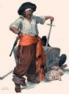
Bathing machine – Little huts that could be rolled into the water so men and women could get changed without anyone seeing them in their swimming costume. | 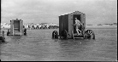
Penny lick - a small glass for serving ice cream that would be filled with a penny’s worth of ice cream and then given back to the vendor to use again. | 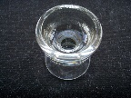
Punch and Judy - a traditional puppet show featuring Mr. Punch and his wife Judy. | 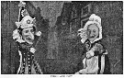
Useful websites:
Pirates - CBeebies - BBC
Over The Deep Blue Sea | Kids Songs | Super Simple Songs (youtube.com)
Curriculum links:
To use basic geographical vocabulary to refer to some of the Physical and Human Features of the Seaside. E.g. beach, cliff, sea, ocean, city, town, village…
To use simple compass directions (North, South, East and West) and locational and directional language [for example, near and far; left and right], to describe the location of features and routes on a map. To locate the UK and its surrounding seas.
To learn about significant events/individuals beyond living memory, including the history of the seaside.
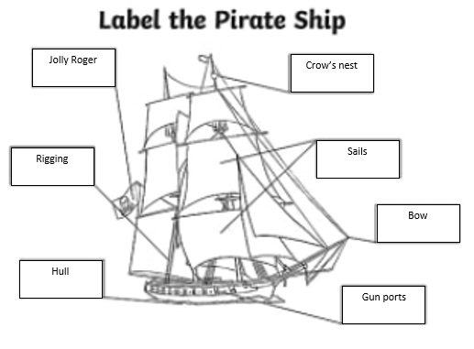

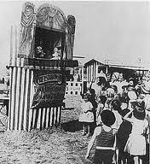
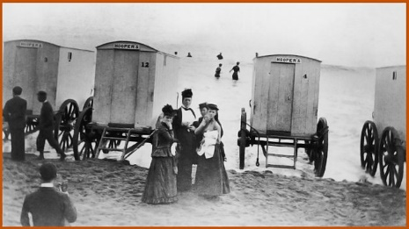
Bow – the forward part of the hull of a ship or boat.
Crow’s nest – a structure in the upper part of the main mast of a ship or a structure that is used as a lookout point.
Hull – the body of the ship.
Rigging – lines and chains used on a ship to help support the masts and sails.

Imagine you are stuck on a desert island… what message would you write and put in a bottle?

