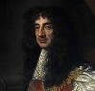
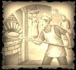
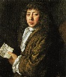
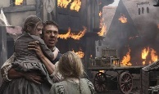
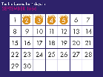
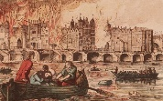
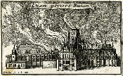
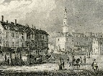
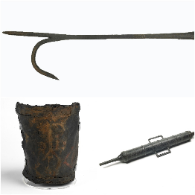
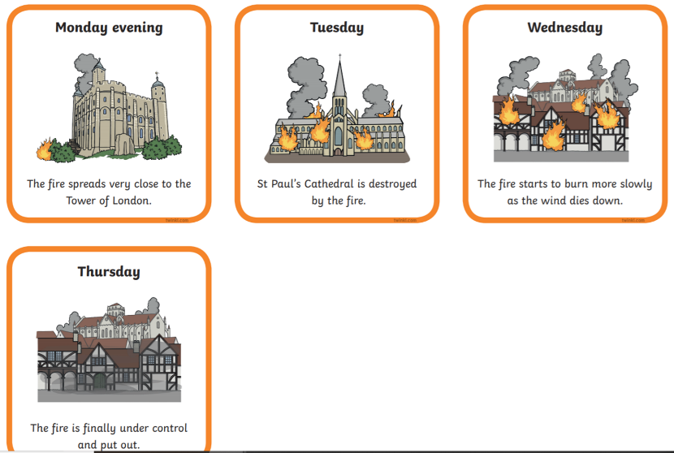
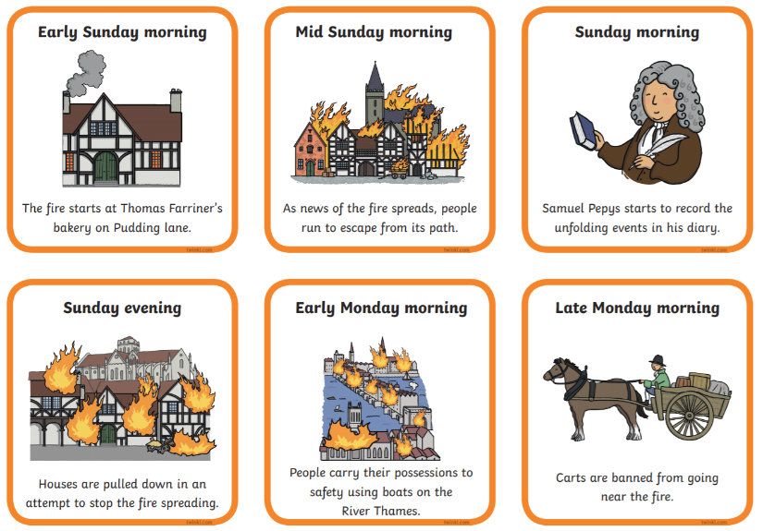
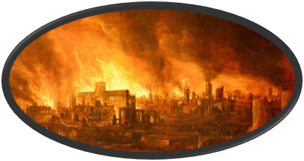
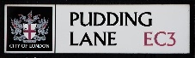
Key vocabulary and significant people
Bakery, Pudding Lane (where the fire began)
London (England’s capital city was destroyed by the fire)
River Thames (Many people fled to the river in attempt to escape by boat)
St. Paul’s Cathedral
(Destroyed in the fire)
2nd September 1666 (The fire began)
Eyewitness (a person who has seen something and can give a description of it)
Samuel Pepys (He is famous for his diary, which provides an accurate picture of life in England in the 17th century.)
Thomas Farriner (A baker in 17th century London. His bakery in Pudding Lane was the source point for the Great Fire of London on 2 September 1666.)
King Charles II (During the fire he stayed in London and took charge of the operation to save the city. His plan was to create fire- breaks.)
Primary source | A first hand account of an event
Secondary source | Accounts written after the event by people who were not directly involved.

Leather bucket
Water squirt
Fire hook
Key learning:
To be taught about…
-Events beyond living memory that are significant nationally or globally.
-Significant individuals in the past.
Useful websites:
http://www.fireoflondon.org.uk/game/
https://historyinnumbers.com/events/fire-of-london/
https://www.bbc.co.uk/cbeebies/puzzles/my-story-fire-of-london-quiz
In sixteen hundred and sixty-six,
London was burnt to ashes and sticks.
Timeline
Great Fire of London
1666

Year 2 Spring term

