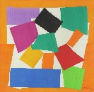
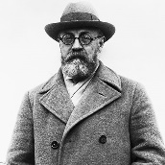
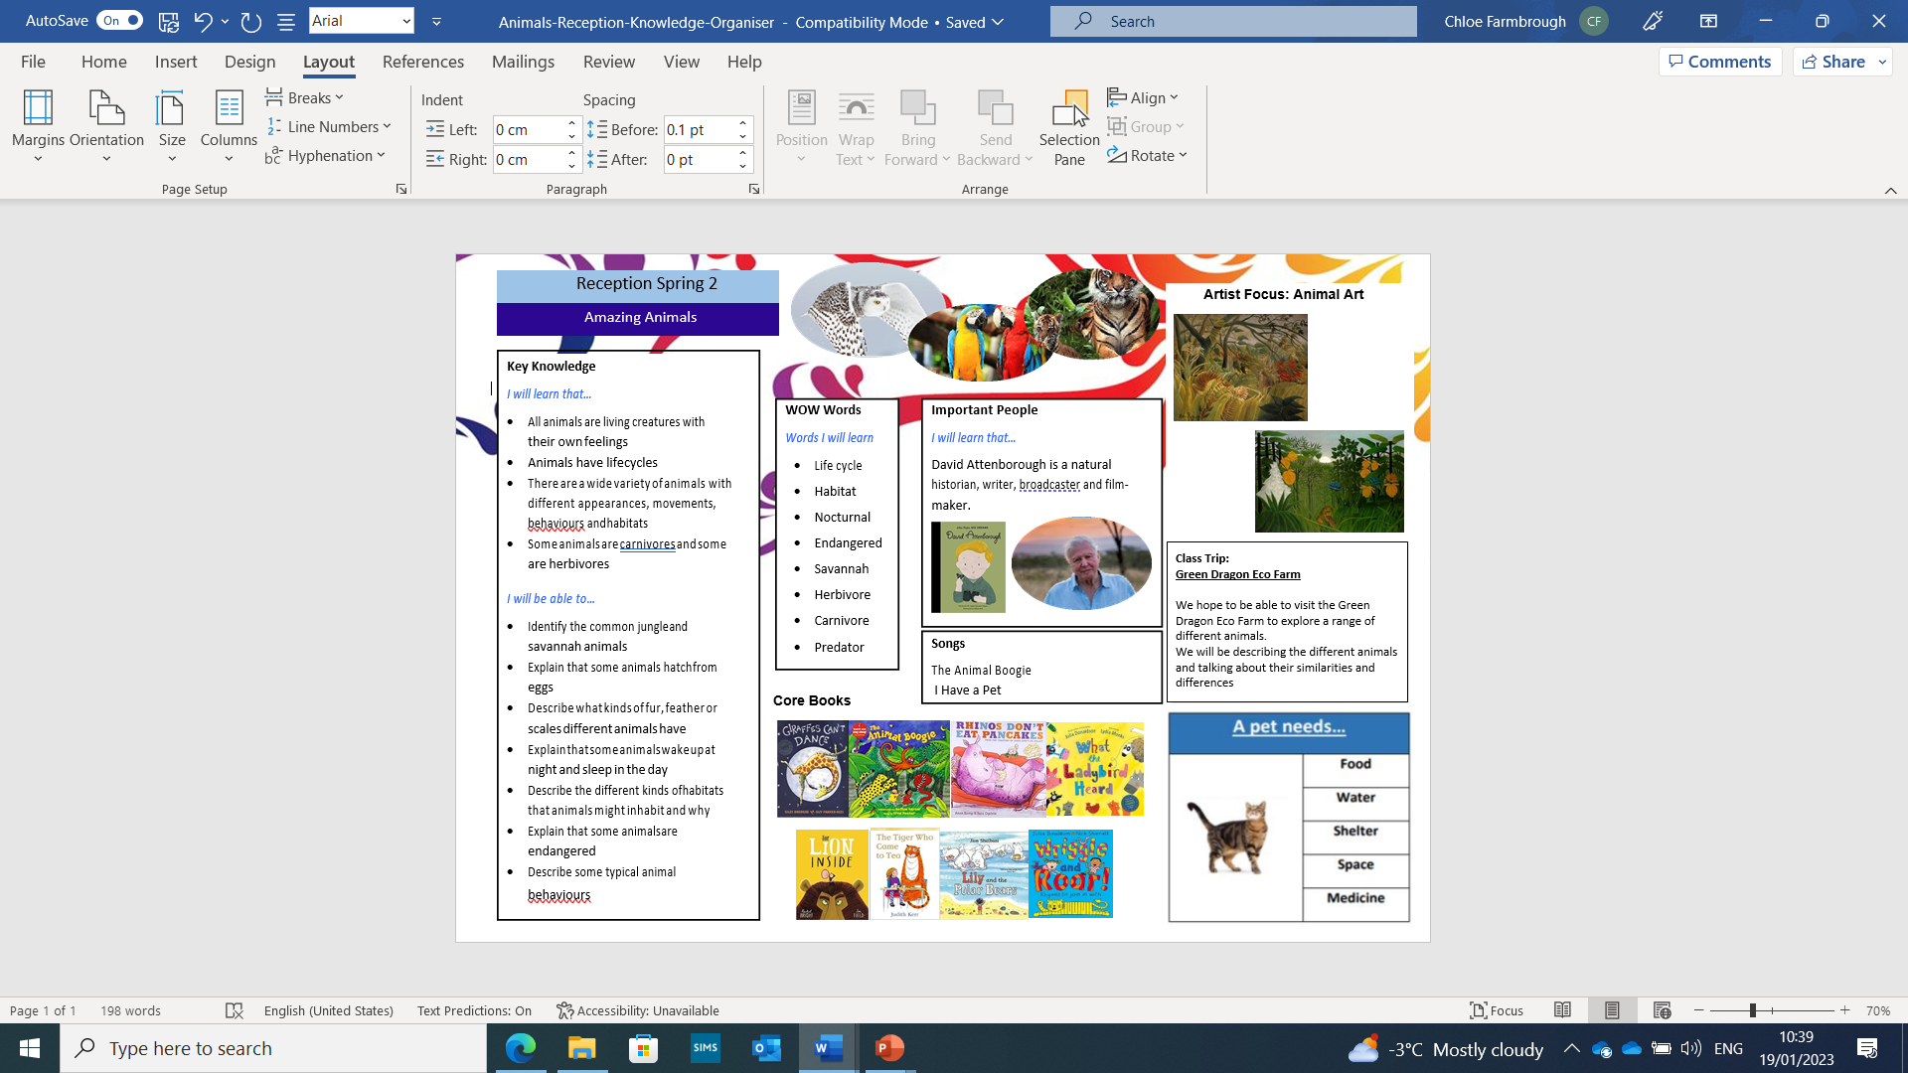
All Creatures Great & Small
Reception - Summer 1
Important People
I will learn that…
David Attenborough is a natural historian, writer, broadcaster and film-maker.

Henri Matisse was a famous French artist, who used bright colours and simple shapes to collage, as he did so with ‘The Snail’.

Key Learning
I will learn that…
- All animals are living creatures with their own feelings
- animals have life cycles
- there are a wide variety of animals with different appearances, movements, behaviours and habitats
- some animals are carnivores and some are herbivores.
I will be able to…
- identify the common jungle and savannah animals
- explain that some animals hatch from eggs
- describe what kinds of fur, feather or scales different animals have
- explain that some animals wake up at night and sleep in the day
- describe the different kinds of habitats that animals might inhabit and why
- explain that some animals are endangered
- describe some typical animal behaviours.
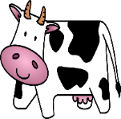
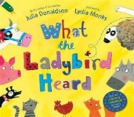
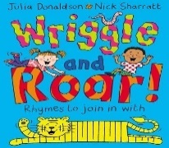
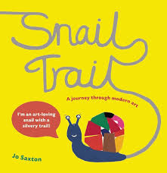
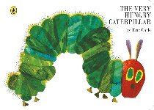
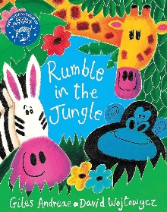
WOW Words
Words I will learn
- Life cycle
- Habitat
- Nocturnal
- Endangered
- Savannah
- Herbivore
- Carnivore
- Predator

Class Trip
Hogshaw Farm and Wildlife Park
At Hogshaw Farm, we will see a range of different animals! What different types of animals do you know?
We will be describing the different animals and talking about their similarities and differences. We will learn about their habitats and what they like to eat.
Core Books


