Life by the Sea
Reception - Summer 2
Important Features
Lighthouse
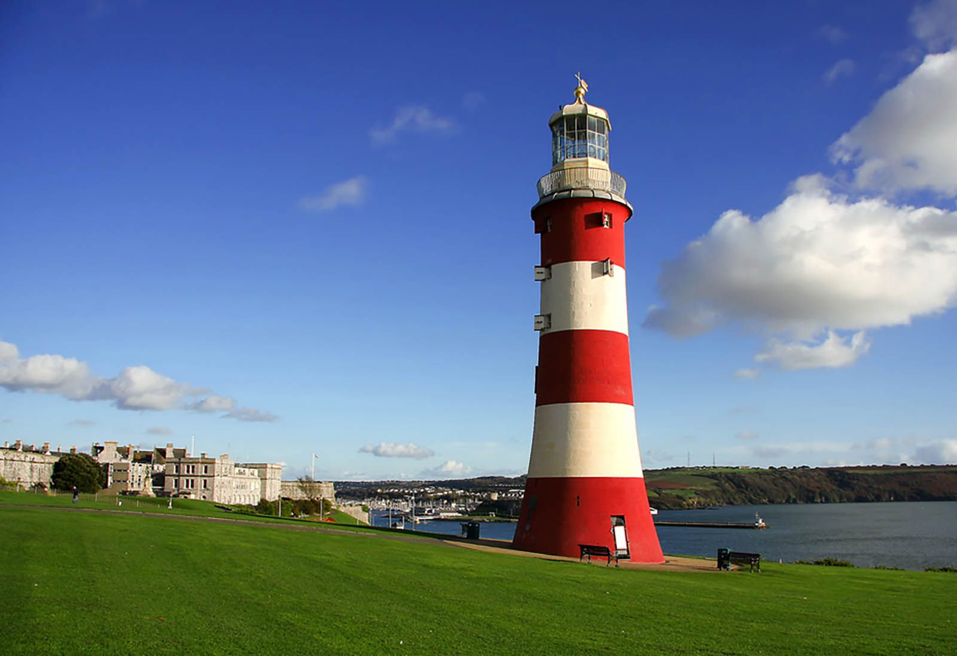
Seashore
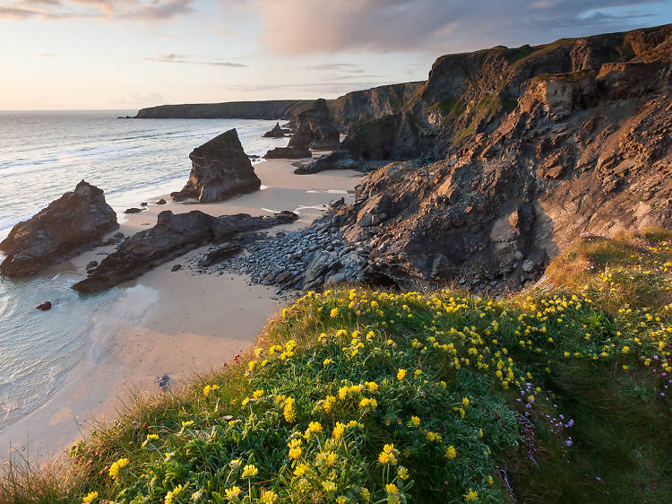

An area of sandy, rocky or stony land which meets with the sea. Many sea creatures live along the seashore!
A light house helps boats to navigate around land by giving out light.
Key Learning
I will learn that…
- a lighthouse is used to guide boats.
- there are many types of creatures that live by the seashore
- similarities and differences between different coastal areas
- it is important to protect yourself from the sun
- we can record our experiences by writing a postcard
- I will be moving on up to Year 1, which involves change.
I will be able to…
- identify animals that live in the sea
- describe what I would take on a beach trip
- explain how I would protect myself from the sun
- write a poem about the sunshine
- write instructions for how to make my very own lighthouse!
- discuss how I feel about moving to Year 1
- refelct on my time in Reception
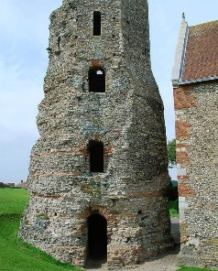
Cohort Experiences:
Sports Day
Summer fun with water & outdoor activities!

Did you know…
The oldest lighthouse in the UK is part of Dover Castle, found on the Dover cliffs, in Kent. Although it has not been functional for many years, it is 2000 years old.
WOW Words
Words I will learn:

- Seaside
- Beach
- Protection
- Seashore
- Limpet
- Lighthouse
- Tide
- Change

Core Books


