Useful websites and other information:
A Year On Your Farm (bbc.co.uk) Cbeebies down on the Farm game
Come Outside - Carrots (youtube.com) – Come Outside ‘Carrots’ Episode.
Arla Virtual Farm | Arla UK (arlafoods.co.uk) – Arla virtual farm tour

Field to Fork
Key vocabulary
Farm – an area of land and its buildings used for growing crops and rearing animals | 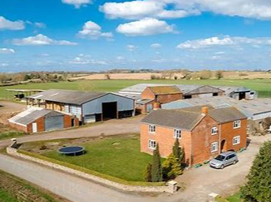
Crop – plants grown over a large area of the farm to produce food | 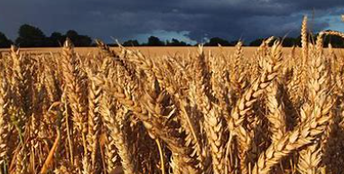
Field – an area of land often surrounded by hedges or fences and used to grow crops or keep animals. | 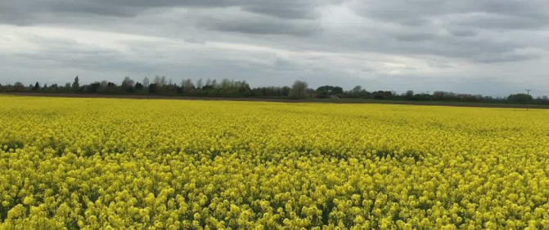
Pasture – fields covered in grass or other low plants which are grown for animals to graze on. | 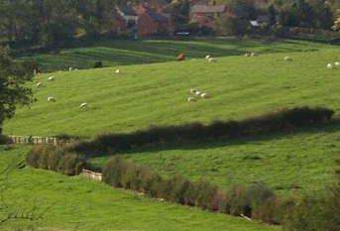
Stable – a building for keeping animals, especially horses. This is usually divided into separate stalls (areas) for each animal. | 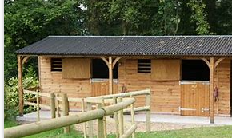
Barn – a large farm building used for storing grain, hay, straw or keeping livestock. | 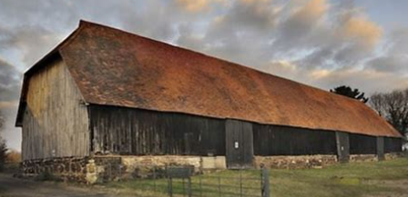
Pigsty or pigpen – an enclosure outside with an area for pigs to shelter in | 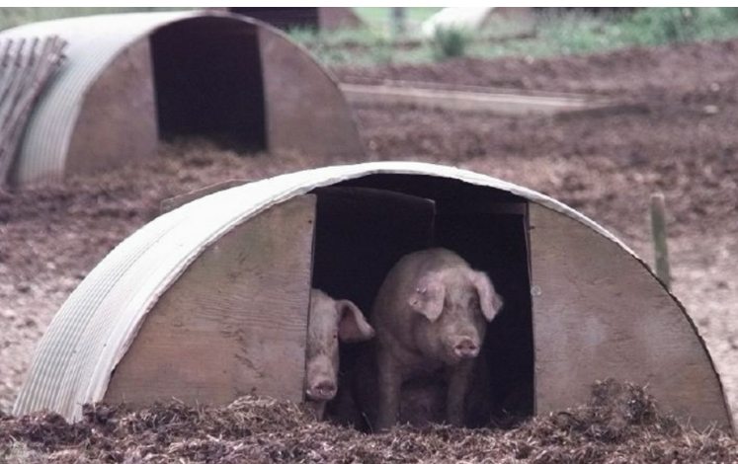
Milking – to draw milk from a cow by hand or by machine | 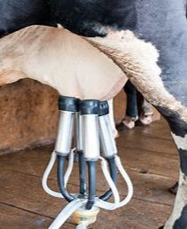
Dairy – the building where milking and storage or milks takes place. A word also used for food containing milk. | 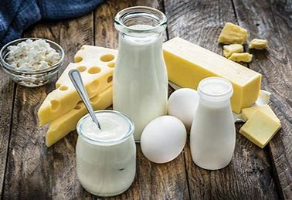
Tractor – a powerful motor vehicle used on farms for pulling equipment and trailers. | 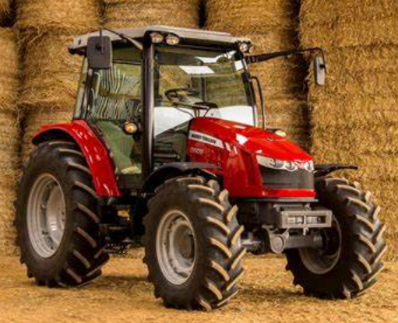
Plough – farm equipment with large blades which is usually drawn behind a tractor to cut grooves / furrows into the earth and prepare it for planting seeds. | 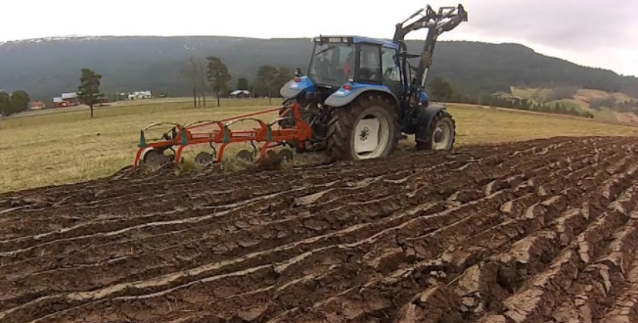
Harvesting – to gather in the crops from where they are growing. | 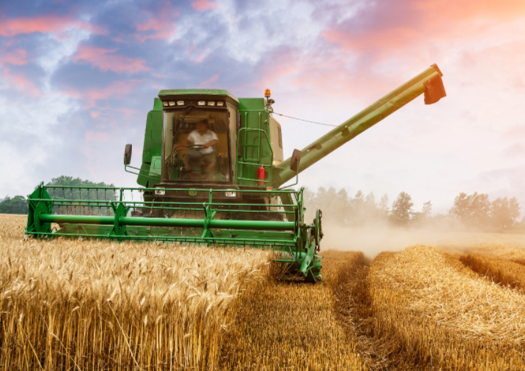
Seeds – a tiny plant enclosed in a protective covering which can grow into a new plant. | 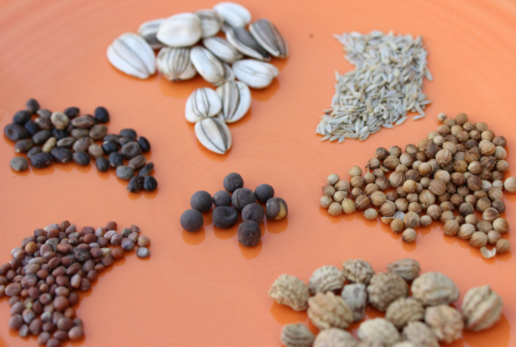
Seasons – Four parts of each year marked by particular weather patterns and length of daylight. | 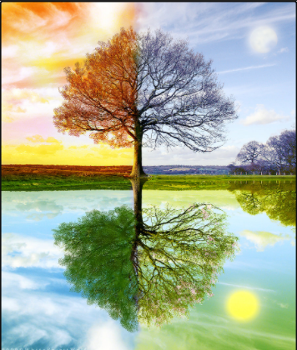
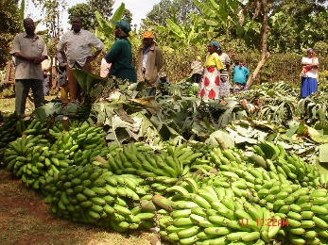
Curriculum links:
To use basic geographical vocabulary to refer to some of the physical and human features of farms. These include the farmyard, milking shed, farmhouse, crop fields, pasture, stables, sheep pen, goat shed, cow barn, orchard, pigsty, hay barn, garden, stream.
To learn how farming has changed during living memory and to compare and contrast farming in Kenya to farming in the UK.
To understand where food comes from and the links between activity on farms and the changing seasons of the year.

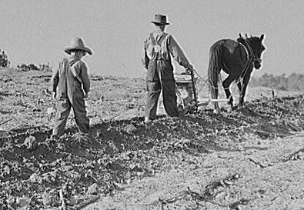
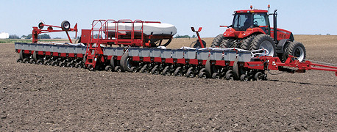
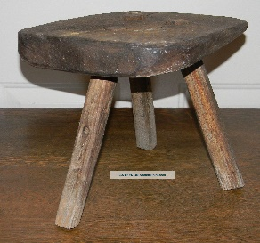
What is this mystery object?
What could it be used for?
Is it from the past or the present?

