The Enchanted Woodland
Year 1
Summer 2
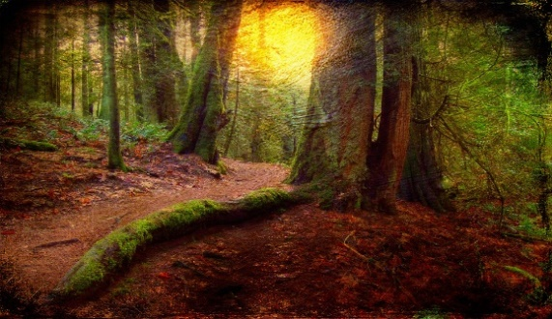
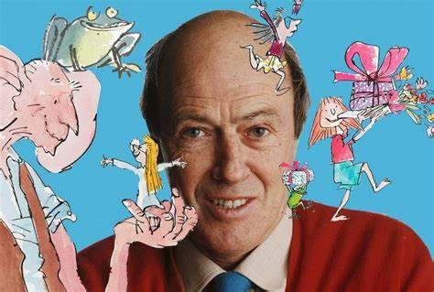
Curriculum Links
To use fieldwork to include a survey of our local area.
To use maps to identify how our local area has changed over time.
To use basic geographical vocabulary to refer to some of the physical and human features of woodlands and our local area.
To compare our local area to a city to see the similarities and differences.
To learn about significant people and places in our own locality.

Roald Dahl
Lived in Great Missenden and wrote about the local woodlands in his stories.

Woodlands
A woodland is a large area of land covered in trees. There are many types of woodland in the United Kingdom.
Lots of different animals live in woodlands. These include mammals, birds, amphibians, reptiles, and invertebrates.

Key words
Forest | 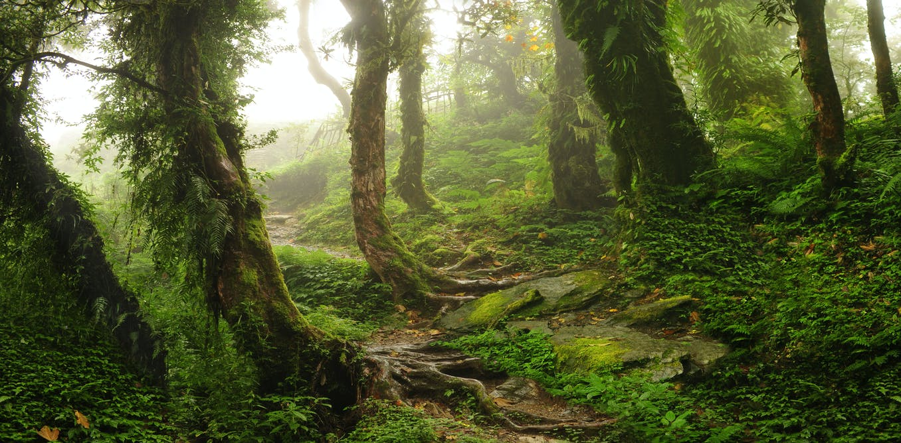 | A large area of land covered with many trees and other plants.
Oak trees | 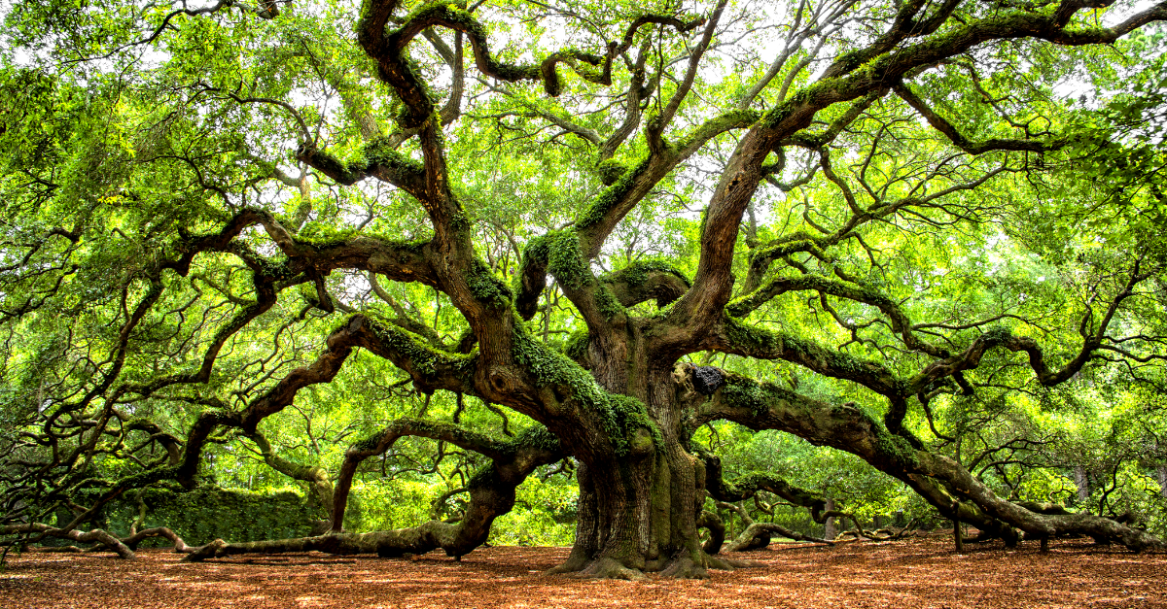 | A tough, lasting wood that comes from a tree
Beech tree | 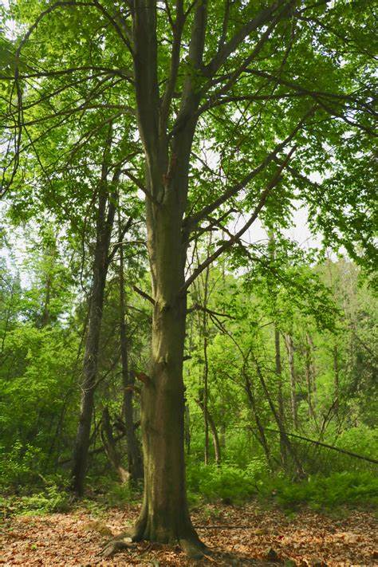 | A tree that has smooth, grey bark.
Evergreen | 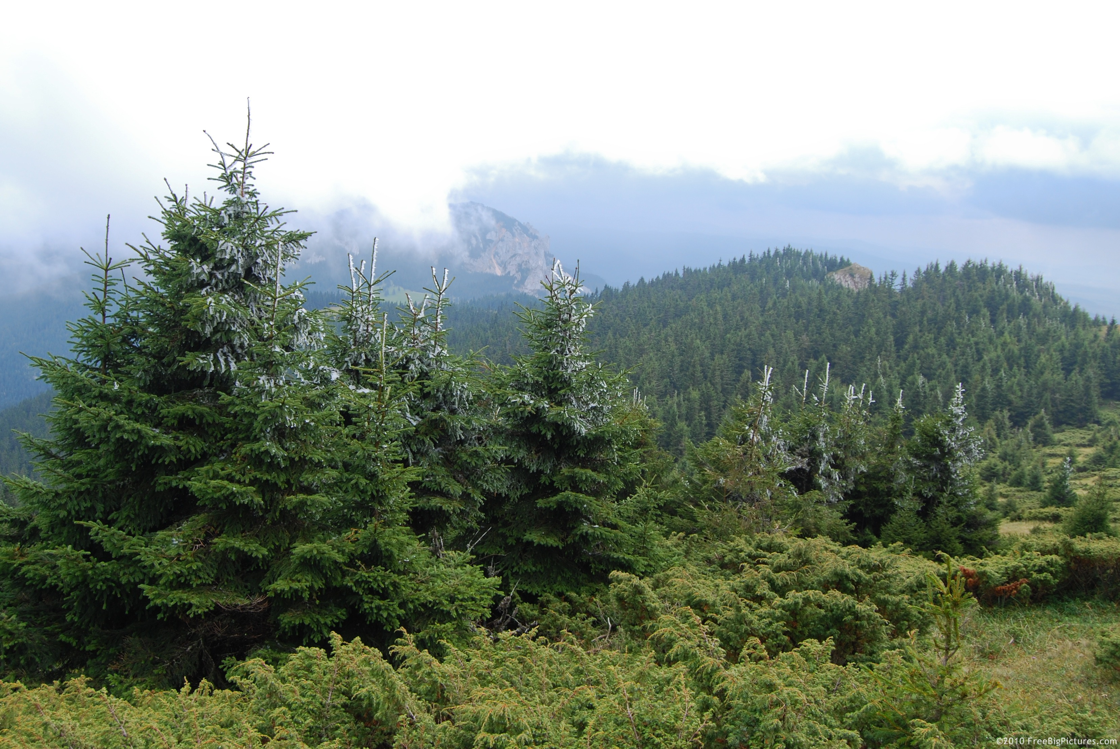 | having green leaves that stay on a plant throughout the year.
Deciduous | 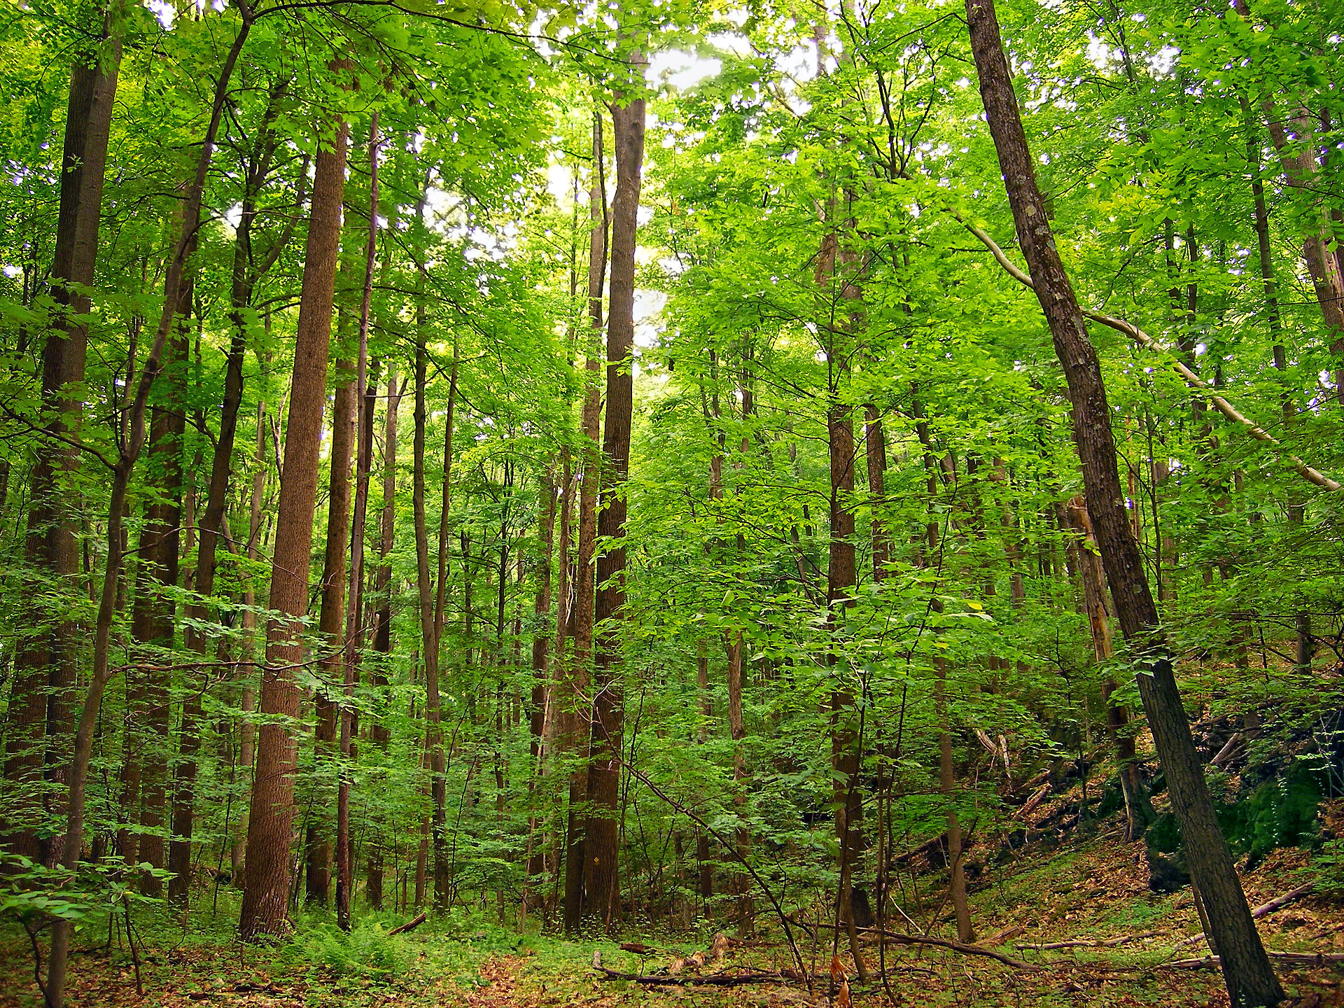 | having leaves that drop off each year.
Rain forest | 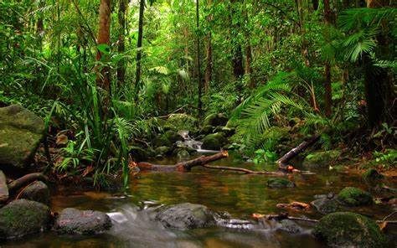 | a dense evergreen forest, mostly found in tropical areas, that receives a large amount of rain all year long.
Deforestation | 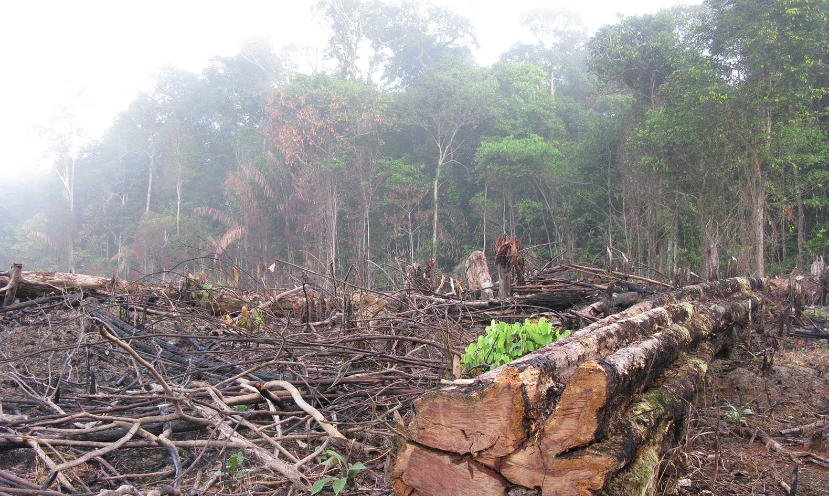 | the act or process of cutting down the trees of a forest.
Maps | 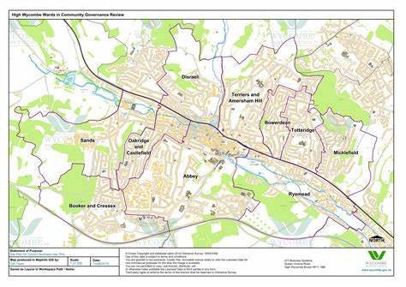 | a picture of a particular area of the earth printed to scale on a flat surface.

