Key vocabulary
Canberra – capital city | 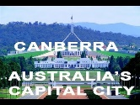  Awesome Australia
Sydney – city in Australia | 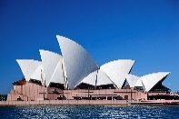
Physical features – (naturally made) For example, beach, cliff, coast, forest, hill, mountain, sea, ocean, river, soil, valley… | 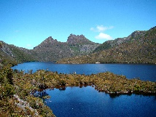
Human features (man made) Things that are built by humans such as bridges, roads, buildings. | 
Aborigine - one of the original or earliest known inhabitants of a country or region. | 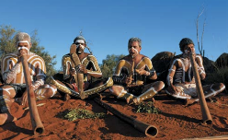
Ayres Rock - Ayer’s Rock or Uluru is a very large sandstone rock. It is a sacred place for the aboriginal people that live there. | 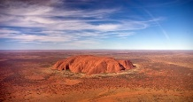
Great Barrier Reef - The Great Barrier Reef is the largest coral reef in the whole world. | 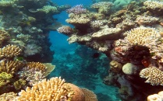
Outback -The Outback is a very dry area of land where hardly anyone lives. Animals such as dingoes and red kangaroos live in The Outback. | 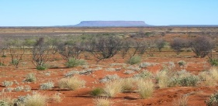
Aerial photograph -taking of photographs of the ground from an elevated position. | 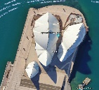

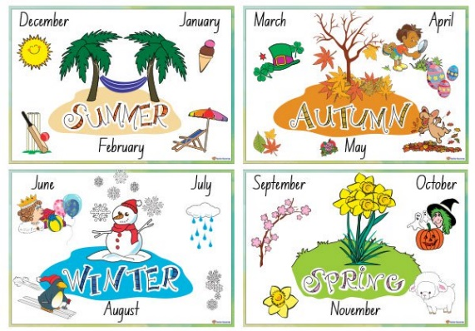
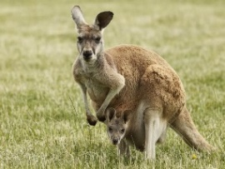
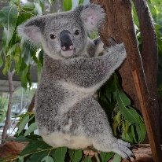
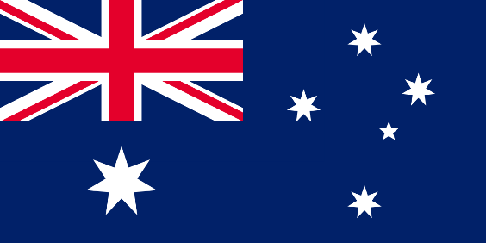
Useful websites:
https://www.natgeokids.com/uk/discover/geography/countries/facts-about-australia/

https://www.youtube.com/watch?v=zmon5Tv6bYU
Key learning:
To understand geographical similarities and differences through studying the human and physical geography of a small area of the United Kingdom, and of a small area in a contrasting non-European country.

To identify seasonal and daily weather patterns in the United Kingdom and the location of hot and cold areas of the world.

To use aerial photographs and plan perspectives to recognise landmarks and basic human and physical features; devise a simple map; and use and construct basic symbols in a key.
Year 2 Summer term

