Key Vocabulary
Ancient Civilisation | The first settled and stable communities in an area that became the basis for later states, nations, and empires.
Artefact | An object made by a human being, typically one of cultural or historical interest.
Continent | A main, continuous expanse of land within the world.
Country | A nation with its own government, occupying a particular territory.
Egyptologist | Any archaeologist, historian, linguist, or art historian who specialises in the scientific study of Ancient Egypt and its antiquities.
Hieroglyphics | Pictures and symbols used by the ancient Egyptians to record messages.
Mummification | A way of preserving a body after death ready for its journey into the afterlife.
Papyrus | Paper made from the stems of a papyrus plant.
Pharaoh | A ruler of Ancient Egypt and most important and powerful person in the Kingdom.
Pyramid | Structures built in the Old and Middle Kingdoms as tombs for the pharaohs.
River Nile | The longest river in Africa which flows through Egypt.
Rosetta Stone | Part of a stone slab which allowed researchers to decipher and read hieroglyphs.
Sarcophagus | A stone coffin adorned with sculptures or inscriptions.
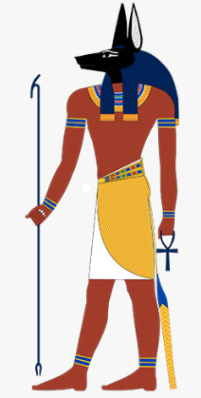
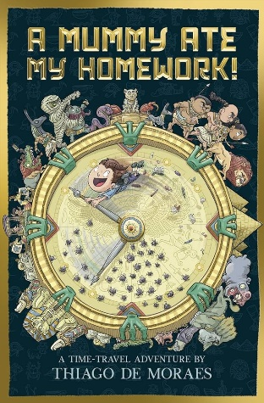
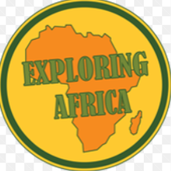
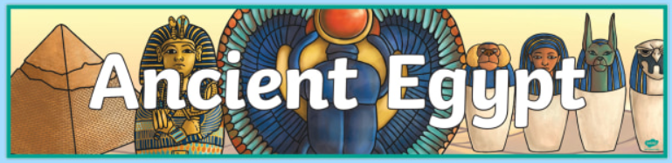
Tutankhamun’s death mask.
Our Learning Journey:
- To identify what I already know and would like to learn about Ancient Egypt and Africa.
- To understand the journey of the river Nile and how it’s changed over time.
- To find out the positive and negative effects of the Aswan High Dam on the River Nile.
- To explore the physical and human geography of the Nile Delta.
- To learn about life in ‘Ancient Egypt’ in comparison to modern Egypt by analysing artefacts.
- To investigate about the way of life in Ancient Egypt.
- To explore how Ancient Egyptians recorded and communicated.
- To explore the importance of Egyptian religion and beliefs in everyday life.
- To explore and understand the ancient Egyptian ritual of mummification and beliefs of the afterlife.
- To investigate burial traditions and examine the artefacts in Tutankhamun’s tomb.
- To investigate the end of the ancient Egyptian civilisation.

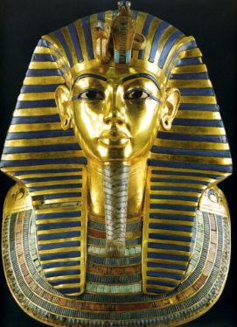

Anubis, God of mummification and the afterlife.
Our reading text.

