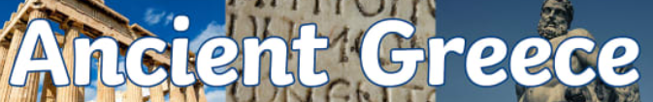
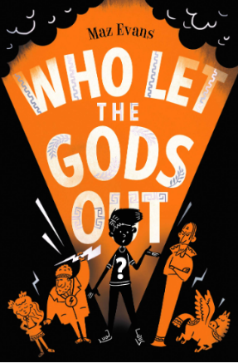


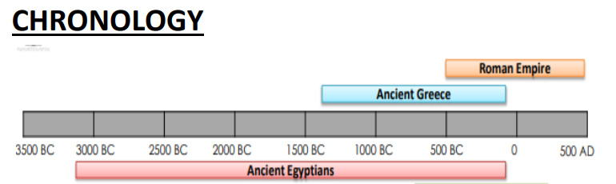
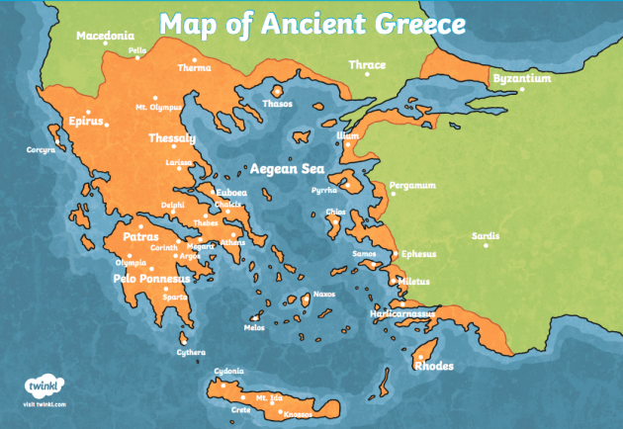
About 2500 years ago, Greece was one of the most important places in the ancient world. The Greeks were great thinkers, warriors, writers, actors, athletes, artists, architects and politicians.
KEY VOCABULARY AND SPELLINGS
Acropolis – an ancient citadel (fortress) usually on a hill.
Architecture – the art or practice of designing and constructing buildings.
Assembly – a group of citizens who turned up to vote.
Athenians – people living in the Greek city state of Athens who valued art, education and culture and lived in a democracy.
Citizen – an inhabitant of a town or city.
Democracy – a form of government where citizens have a say in how they are ruled.
Dictatorship – ruled by one person (a dictator) who has total power over a country.
Doric, Ionic and Corinthian – types of architecture.
Myth – a traditional story explaining the history of people or a natural phenomenon.
Olympics – an athletic event held every 4 years.
Philosophy – the study of the fundamental nature of knowledge, reality and existence.
Spartans – people living in the Greek city state of Sparta who valued strength and military skill and were ruled by a select few.
Guided Reading text:
Who Let The Gods Out? by Maz Evans.
The Greeks lived in mainland Greece and the Greek islands but also in colonies scattered around the Mediterranean Sea.
There were Greeks in Italy, Sicily, Turkey, North Africa and as far west as France.
KEY LEARNING
- To explore aspects of Greek life including daily routines, politics, religion, war and battles and the Olympics.
- To identify the differences between city states, particularly Athens and Sparta.
- - To discover more about the Greek way of life through artefacts, sources, art, architecture and literature.
- To explore the achievements of the Greeks and their influence on the Western World.

