Key Vocabulary
Palaeolithic | The Early Stone Age – 2.5 million years ago to 10000 years ago.
Mesolithic | The Middle Stone Age – 8000BC to 4500BC.
Neolithic | The Late Stone Age – 4000BC to 2500BC.
Archaeologist | A person who studies human history and prehistory through the excavation of sites and the analysis of artefacts and other physical remains.
Settlement | A place, typically one which has previously been uninhabited, where people establish a community.
Flint | A sedimentary rock often used by people in the Stone Age to make tools/weapons and start fires.
Hunter-gatherer | A member of a culture in which food is obtained by hunting, fishing, and foraging rather than by farming.
Hillfort | Hillforts were places where Celtic communities would live together.
Stonehenge | Stonehenge is a mysterious prehistoric monument found in Wiltshire, England.
The Celts | The Celts were a collection of tribes with origins in central Europe that shared a similar language, religious beliefs, traditions and culture.
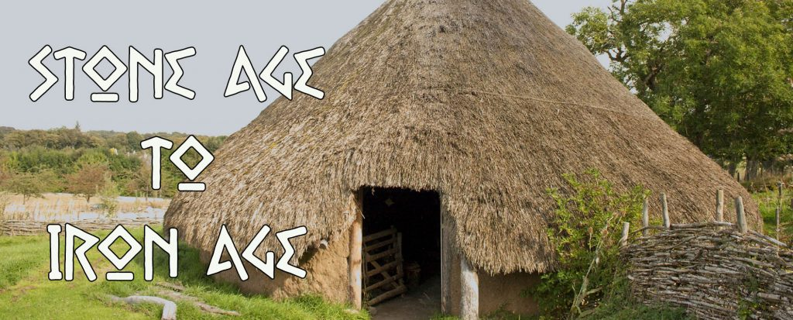
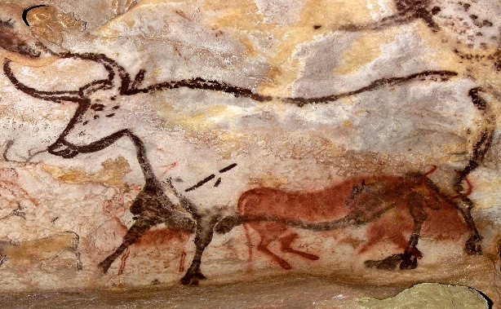
Key Learning:
- To order historical events chronologically and discover ways Stone Age people communicated.
- To compare our lives of Stone Age people.
- To analyse Stone Age artefacts and consider what they tell us about Stone Age life. (Chiltern Open Air Museum).
- To explore what it means to be a Hunter-gatherer.
- To explore the significance of Stonehenge (Biscuithenge).
- To investigate the Bronze Age in Britain and discover the Beaker People.
- To investigate what the Amesbury Archer tells us about life in the Bronze Age.
- To investigate the Iron Age in Britain.
- To design an ideal settlement for an Iron Age Hillfort.
- To investigate what lead to the Celtic way of life and the end of The Iron Age.
Hunters and the Hunted

Our texts:

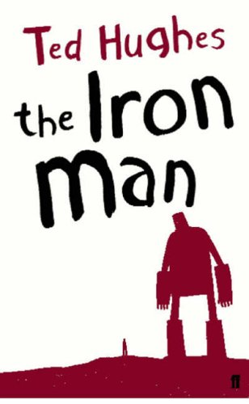
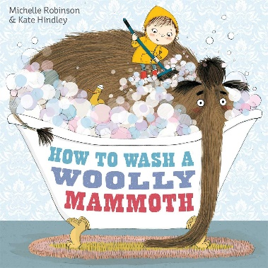
Cross-curricular:
Guided Reading texts – The Iron Man
English – How to wash a Woolly Mammoth.
Science – Rocks and Fossils (Geology Rocks!)
Cultural Capital:
Chiltern Open Air Museum visit

