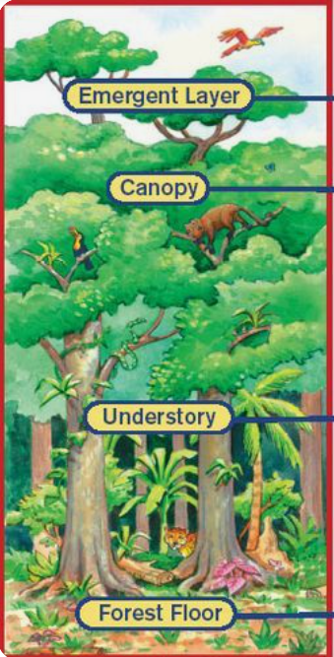
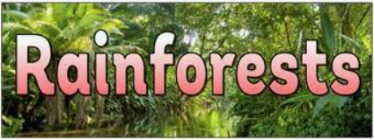
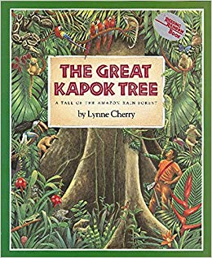
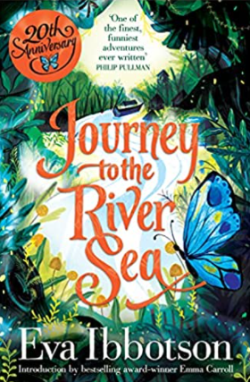
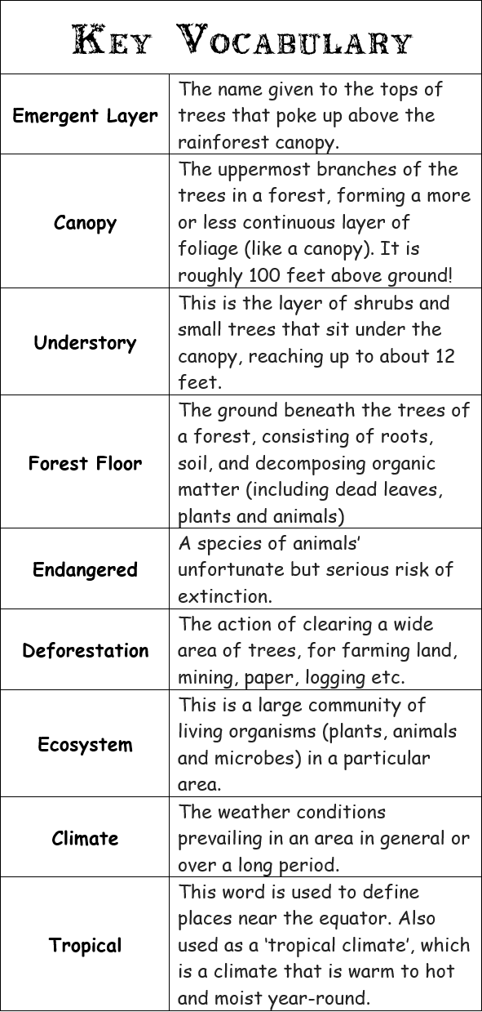
Journey to the River Sea by Eva Ibbotson.
The Great Kapok Tree by Lynne Cherry.
Useful websites:
https://school-learningzone.co.uk/key_stage_two/ks2_geography/rainforests/rainforests.html
https://www.natgeokids.com/uk/discover/geography/physical-geography/amazon-facts/
Key Learning
- Recognise the features of a rainforest, including the difference between the layers.
- Explore the humans, animals and plants that live within a rainforest ecosystem.
- Understand the climate and conditions of the rainforest and identify where they are found in the world.
- Locate the Amazon Rainforest, the country of Brazil and the continent of South America and the equator using a map/atlas.
- Compare the Amazon Rainforest to other locations.
- Study the global impact of deforestation and the effects this has to the habitat within and surrounding the rainforest.

