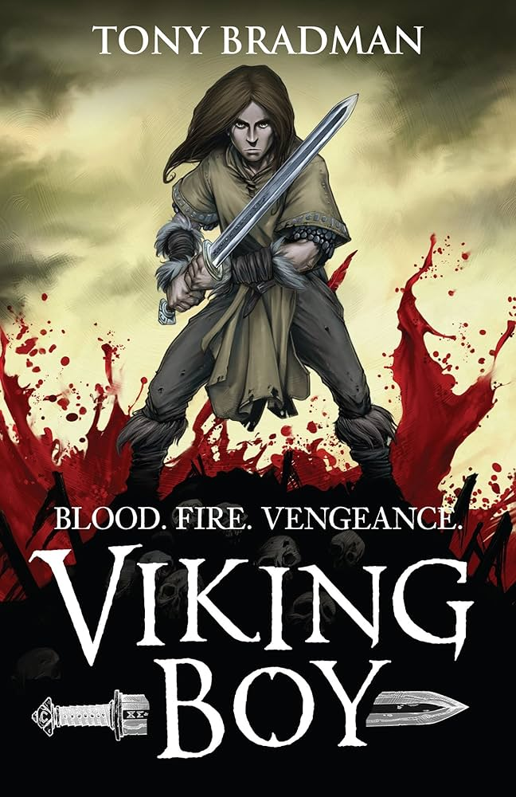
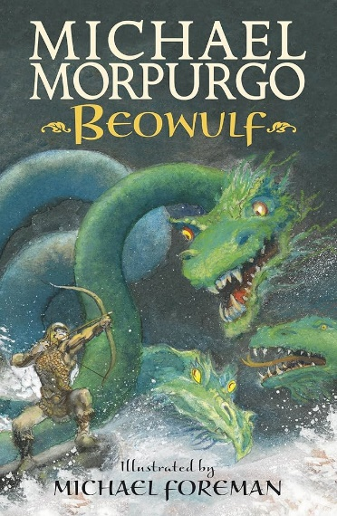
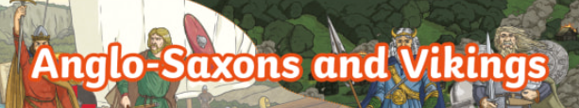
Key learning:
- To locate Scandinavia’s countries and major cities on a map.
- To explore the human and physical geographical features of Scandinavia.
- To understand who the Anglo-Saxons were, where they came from and why they settled in Britain.
- To understand how the Anglo-Saxons have influenced Britain.
- To explore Anglo-Saxon village life and roles.
- To explore the importance of the Sutton Hoo discovery and explain what the artefacts found teach us about Anglo-Saxon culture.
- To understand who the Vikings were, where they came from and why they invaded Britain.
- To explore the roles and rankings in Viking society.
- To consider why the Anglo-Saxon, King Alfred, is remembered as Alfred the Great.
- To explore Viking beliefs and the practices linked to these.
- To explore how Britain became a united country and Anglo-Saxon and Viking rule came to an end.
- To study the Bayeux Tapestry and its depiction of the Norman Conquest.

BBC Bitesize – KS2 - Vikings
Key Vocabulary:
Human features – Man-made features which have been built or made by people.
Physical features – Natural features which would be there even if there were no people around.
Scandinavia – A region in northern Europe which is made up of three countries: Norway, Sweden and Denmark.
Chieftain – An Anglo-Saxon leader of the village.
Artefact – A man-made object that belonged to an earlier time that has historical or cultural significance.
Hierarchy – A system in society where groups are assigned varying levels of power and status based on factors like social class, jobs and gender.
King – The most powerful Viking who ruled the people. Everyone looked up to him.
Jarl – Rich Viking landowners or traders who employed men to work for them. The nobles in society.
Karl – Everyday Viking people like farmers and craft workers.
Thrall – Enslaved people who did the hardest, dirtiest jobs.

